*Cofe District*

DEtailed Functional Documentation

Version 2.0

09/06/2017

Prepared By:

FISAL HASSAN

VERSION HISTORY

|  |  |  |  |  |  |
| --- | --- | --- | --- | --- | --- |
| **Version #** | **Implemented**  **By** | **Revision**  **Date** | **Approved**  **By** | **Approval**  **Date** | **Reason** |
| 1.0 | Fisal Hassan | *09/06/2017* |  |  | Initial Documentation |
| 1.1 | Mawaqaa | *18/06/2017* |  |  | Updated with Client comments |
| 1.2 | Fisal Hassan | *23/06/2017* |  |  | restructured |
| 2.0 | Ferhat Raj | *03/07/2017* |  |  | Client comments |

TABLE OF CONTENTS

1. Introduction 4

Purpose of The detailed Specification Document 4

PROJECT OVERVIEW 4

2. Scope Of Work 5

3. Website Structure 7

4. Administration Section 61

4.1 Super Admin 61

4.1.1 Order Management 62

4.1.2 Coffee Shop Management 64

4.1.3 New Coffee Shops 76

4.1.4 Area Management 76

4.1.5 User Management 77

4.1.6 Resource Strings 81

4.1.7 Home Banner Management 82

4.1.8 Content Management 84

4.1.9 Advertisement Banner Management 84

4.1.10 Notification Management 86

4.1.11 Reports 86

4.2 Coffee Shop Admin 89

4.2.1 Order Management 90

4.2.2 Coffee Shop Management 92

4.2.3 Delivery Menu Management 94

4.2.4 Branches Management 99

4.2.5 Latest Offers Management 103

4.2.6 Catering Management 103

4.2.7 Tips Management 103

4.2.8 Reports 104

5. COMMON FUNCTIONALITIES 104

5.1 Email Notification 104

5.2 Audit Track 105

5.3 Language 105

6 ProJect Documentation Approval 106

1. Introduction

## Purpose of The detailed Specification Document

This document provides a comprehensive and detailed architectural overview of the system design in order to give the development team guidance on architecture of the system to be developed. Its intended audience is the Business Sponsors, Project manager, project team and development team. Some portions of this document such as the user interface (UI) may on occasion be shared with the client/user, and other stakeholder whose input/approval into the UI is needed.

## PROJECT OVERVIEW

**Project title**

Cofe District – Online Coffee Delivery & Pickup application

**Terminology**

* MAWAQAA – National Web Solutions Company
* UI/GUI – User Interface/Graphical User Interface. Portion of the product where the user sees and interacts with.
* UX – User Experience
* QA – Quality Assurance. A planned and systematic process necessary to provide adequate confidence that the product optimally fulfils customer expectations
* Admin – Administrator Section
* Project Owner – Mawaqaa Client or an authorized representative
* Development Change – Not Covered under Current Scope

1. Scope Of Work

The Scope of work will be covering Online Coffee Delivery & Pickup application for Cofe District. The website will be available in English and Arabic.

The Following are the functionality for Online Coffee Delivery & Pickup application

* Develop & build a world class Online Coffee Delivery & Pickup application.
* Develop an intuitive website architecture that includes easy to use navigation, site structure, colour schemes, user experience, site usability and interactive features.
* There will be the below User roles
  + Admin

Admin receives service requests from Cofe District or Coffee Shops and branches

The admin need to report / add a note in the CMS when there is any issue

If the driver faced any issues when he/she is going to deliver the order like (flat tire, accident)

Or any other reasons, he/she notify the concerned admin.

Admin will re-check another available driver to continue the delivery process.

Admin check the available drivers who can deliver the order.

Admin assign the order for the one of the available drivers.

When a driver accepts to deliver the order, then admin can start monitoring the delivery process.

* + Driver
    - These users are for delivering the orders of customers from the specific Coffee Shops.
    - There will be lists of drivers for Cofe District.
    - The driver should notify the concerned admin of the time for the following phases.
    - When the driver accept the order.
    - When the driver be near of the customer.
    - When the driver delivered the order.
  + Customer
    - Registered users from website and mobile applications, who will order and buy items from different Coffee Shops.
    - The logged in users can view the full details of his/her own order, which contains the order details and driver details.
    - The guest users will receive only the order details.
  + Dispatcher
    - These user will check available drivers that can deliver the order

There are 3 types of Dispatcher:

1- Dispatcher for Cofe District

Dispatcher receives orders from Cofe District or from a Coffee Shop which doesn’t have available driver.

2- Dispatcher for Coffee Shop

Dispatcher receives orders from a specific Coffee Shop or the Coffee Shop related branches

Dispatcher checks the available drivers who can deliver the order.

Dispatcher assigns the order for the one of the available drivers.

When a driver accepts to deliver the order, then dispatcher can start monitoring the delivery process. Then the logged in users will receive a SMS notification or he/she can track his own order from “Track my Order” section in mobile app.

Guest users will only receive SMS because he/she cannot user “Track my Order” in mobile app.

The logged in users can view the full details of his/her own order, which contains the order details and driver details.

The guest users will receive only the order details.

The driver should notify the concerned dispatcher of the time for the following phases.

* + - When the driver accept the order.
    - When the driver be near of the customer.
    - When the driver delivered the order.

In all of these phases the customers will receive a notification.

If the driver delayed to deliver the order, then the driver will send a notification for the concerned dispatcher by using a mobile app.

If the driver delayed to retuned back to the Coffee Shop, the driver will send a notification for the concerned dispatcher

The dispatcher will get a notification on his own dashboard.

3- Dispatcher for Service Company

Dispatcher receives service requests from Cofe District or Coffee Shops and Coffee Shop branches

If the driver faced any issues when he/she is going to deliver the order like (flat tire, accident)

Or any other reasons, he/she notify the concerned dispatcher.

Dispatcher will re-check another available driver to continue the delivery process.

1. Website Structure

The following listed are the approved components for website structure for Cofe District.

**Cofe District Website Structure**

1. Welcome Pop up/Advertisement Pop up //Once closed enter the website
2. Header
   1. Logo
   2. Login //Pop up

2.2.1 Signup Page //Forgot password, Remember me

* 1. My Account
     1. My Orders
     2. My Profile
     3. Saved Addresses
     4. Logout
  2. Arabic/English
  3. My Cart

1. Banner Section
   1. Search by Location
      1. Search Page with Search by location and Coffee Shop and List of All Coffee Shops //The top icon will reflect the selected location
      2. Menu page with Categories, General Information, ratings & Products //If the Shop is closed, user will not be able to order now but can schedule.
      3. Product Description page //Size is required.
      4. My Cart Page //Delivery Fees can be changed from CMS
      5. Checkout Page // Login/Register, Order Summary, Delivery Address, time & Payment Gateway – Order now or Schedule(per day or range) pop up
2. About us
   1. About us info
   2. Delivery<30 mins
   3. No minimum orders
   4. Fixed Delivery Cost
3. Order flow steps
4. Advertisement Banners (1 Main and 3 Sub)
   1. Main Banner – Slideshow
   2. 2 Sub ads
   3. Add your Coffee shop form pop up
5. Footer
   1. Browse
      1. Home
      2. About us //Content, Video & Images
      3. Careers
      4. Media
      5. Cofe Blog //Search Bar with Blogger or date, with Become Blogger option (Pop up form) and list of Blogs.
         1. Cofe Blog article with Image //Share on social media
      6. Contact us
   2. Orders
      1. My Profile
      2. My Orders //Receipt will be printed by the Coffee Shop & Users will have it
         1. Current Orders
         2. Completed Orders //Users can reorder
      3. Order Summary //Track Order
      4. FAQs //Questions & Answers
      5. Privacy Policy
         1. Profiles
         2. Security
      6. Terms & Conditions
         1. Order Cancellations
         2. Licenses
   3. Cofe Club
      1. My Gift cards //List of Gift cards with Order summary & Payment gateway
         1. Gift Cards // Gift card with Send to friend form pop up & View Receipt
      2. Offers // Linked to the Coffee Shop Offers tab
      3. Catering //Form which will ask for Customer details, saved in cms
   4. Contact // Phone and Email
   5. Download Android & IOS icons
   6. Copyright info
   7. Social Media icons
      1. Facebook
      2. Twitter
      3. LinkedIn
      4. YouTube
      5. Instagram

**Website Structure in details**

**Home page Contains:**

Home page will be the landing page for the Cofe District website. By default the landing page will be in English version.

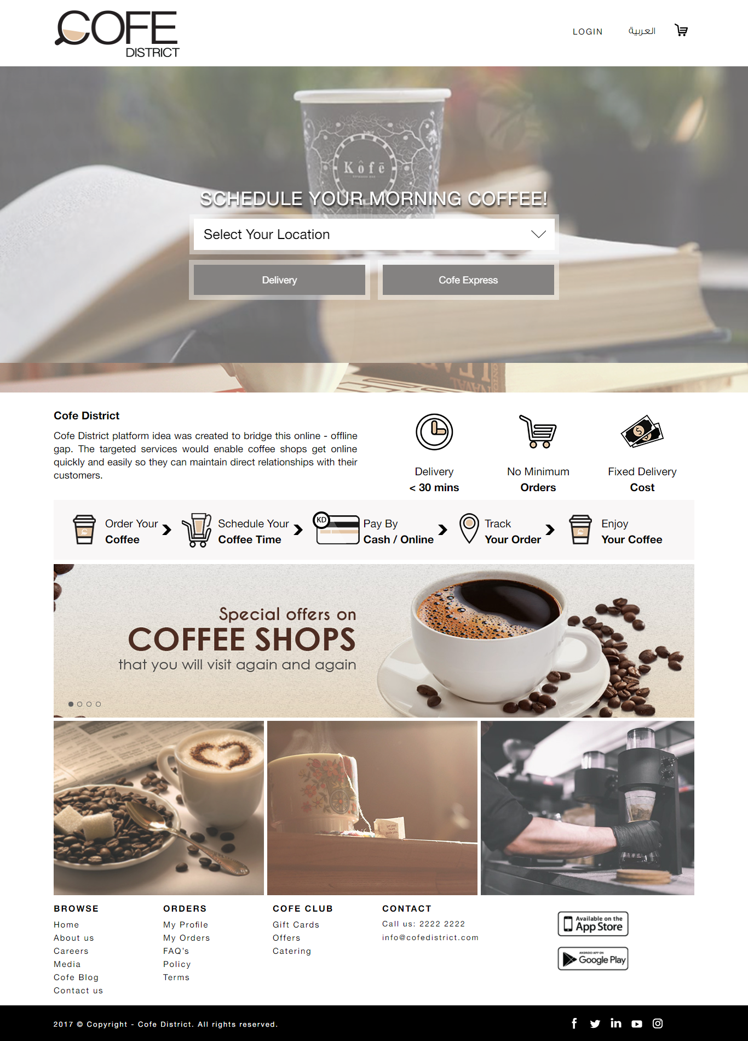

Following are the components in the home page

**1. Welcome Pop up**

The Pop up (advertisement) which will be shown during first load if can be managed from admin panel.

2. Header

The header contains logo on left corner, login link, language switcher and cart area on the right corner.

**2.1 Logo**

The Cofe District Logo and name will be on the left corner. The logo will be linked with the home page of the website English/Arabic.



**2.2 Login**

The login link in the website header allows the customers to login to the website as registered user and can manage his/her account from the profile pages.

When the user clicks on the login button, the user will be redirected to the login page in the website. The login page will have the following details

* + - * Login section
        + Email
        + Password
        + Login
      * Forgot Password?
      * Create New Account

These are the options available in the login page of the website. The login section allows the user to login to the website using his/her registered email id and password. The user have to enter the valid and existing email and password to login to the website, otherwise the system will show the error message and will not allow the user to login.

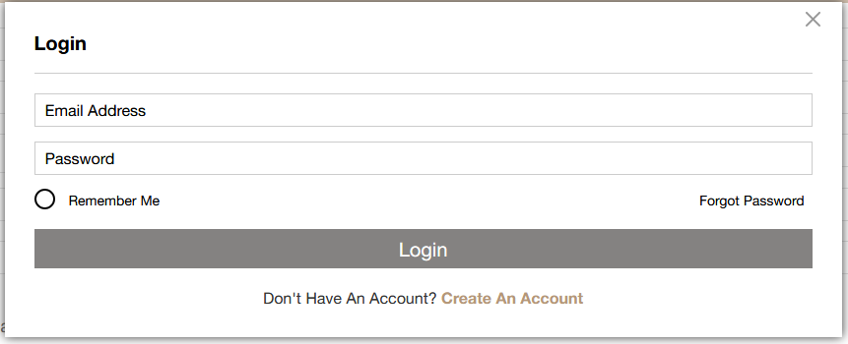

**Forgot Password**

This will allows customer to reset his account password if he/she ignored the password. By clicking on the “forgot password” link, the user will be redirected to a page where he/she needs to enter his/her email Id that is registered in the website.

The system will check the entered email id of the user is registered in the system or not. If not, the system will show a message to the user that the email id is not exists. If the email id is exist, then the system will send a password reset link to registered email Id and will show a message to the user that the link is sent to the email id.

This link will be for one time use and after the user reset his account password with the specific link, the link will be expired. The user can open the password reset link that he received in the email and then he can enter the below details to complete the password reset

* + - * New Password
      * Re-enter Password

After submitting these details, the password for his/her account will be updated and the user will be redirected to the login page of the website.

**2.2.1 Signup Page**

When the user clicks on the “Create New Account” link in the login page or “Register” button from the website header, the user will be redirected to the “Customer Registration page”. This allows the non-registered users to create accounts in the Cofe District website.

The page will have following fields.

* First name
* Last name
* Email,
* Phone,
* Gender,
* Date,
* Country
* City
* Password
* Confirm password

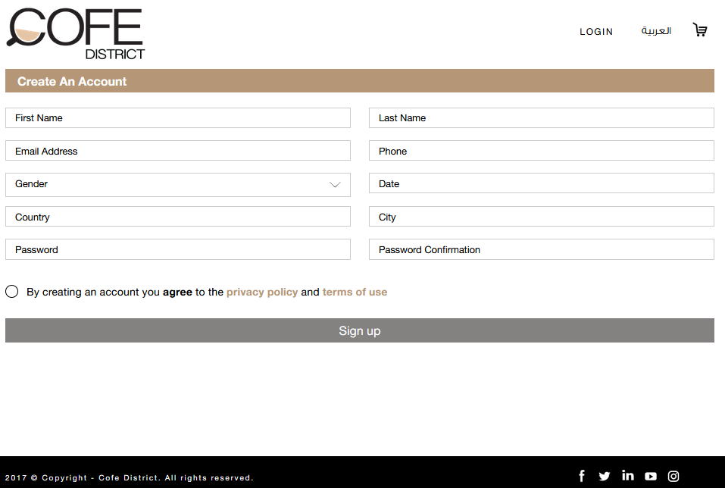

Cofe District website allows the non-registered users to create account in the Cofe District website as customer.

Users email id will be used to login to the website and so email id will be unique. So using one email id, the user can create only one account in Cofe District website.

There will be a form for the customers to create new account in the Cofe District website. The form will have the following details

The user have to provide details for all the required fields of above and then he needs to accept the terms and conditions of Cofe District for creating new account.

There will be option to select the current location of the user in Google map or user can select location manually from Google map. This will fill the delivery area and then user can enter the other details.

After creating the account, the system will send email notification to the user in the registered email and the user will be redirected to the login page of the Cofe District website.

**2.3 My Account**

The logged in users can view their orders, they can edit their profile. The page will have an option like below display on the right corner.

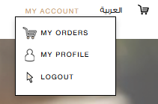

**2.3.1 My Orders**

This section will display the order history of the specific user. The order will be listed in accordion style and there will be option for the user to select the page size to view the list. The page size will be 10, 50, 100, 200 and the list will be with pagination.

The list will show the following details by default

* + - * Date
      * Delivery Address Name
      * Total Price in KD
      * Coffee shop name”
      * “Re-order”

Clicking on each order will show the full details about the order, and this will have the following details

* + - * Details of each ordered dish
        + Coffee Shop Name

Item Name

Quantity

Unit Price

Grand Total

Current orders section displays the latest orders for different Coffee Shops. This section will be displayed as a slider, so that the latest orders will be displayed randomly in a specific time interval.

The current orders will be listed as like below

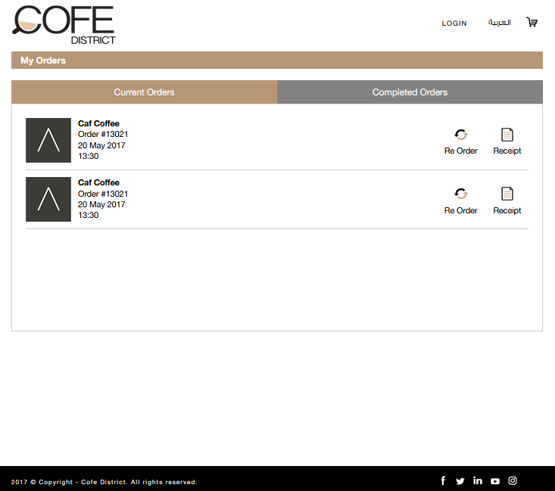

**Re Order**

This feature allows the logged in customer to re order any orders from the order history page. Each order in the order history will have a button called “Buy it again”, this allows the customer to re order the selected order.

When the customer selects re order, the items in the selected order will be added to his/her cart. During re order when an item is not available or the selected quantity is not available for any item, the system will show an error message to the customer about the non-availability of the specific item. Then the customer can remove/manage the quantity of the item to proceed to re ordering.

The re ordering will add the items to the cart and the customer can add more items to cart in the normal way if he/she needs add more items other than the items in the re ordered order. After managing the items, the customer can proceed to checkout in the normal way.

All finished orders section displays the all the completed orders from different Coffee Shops. This section will be displayed as a slider, so that the latest orders will be displayed randomly in a specific time interval.

All the finished orders will be listed as like below. Each list will have a summary and a receipt.

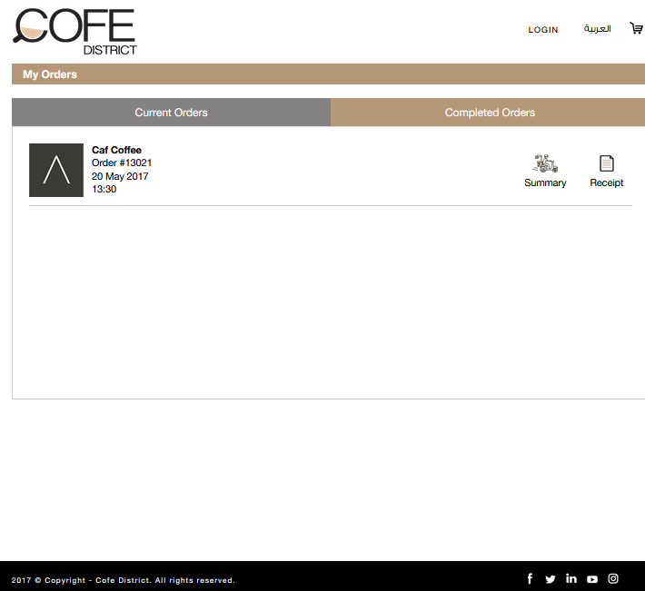

The order summary will be like below

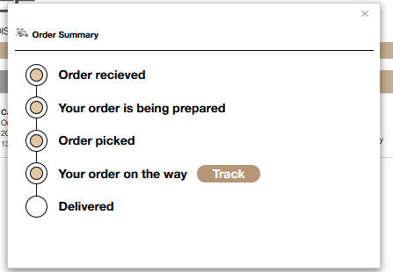

**Order Summary**

This section will have the details of each Coffee item he/she ordered as below

* Payment methods available
* Menu
  + Item name
  + Quantity
  + Unit Price (In KD)
  + Total Price (In KD)
  + Special request (Text area)
  + Remove button – For removing items from the order

The user can select the delivery time as below

* + Now
  + User can select date till the post order date that accepts the Coffee Shop
  + If today is Sunday and time is 12:30 PM and Coffee Shop post order date accepts 3 days then the list will have date and time from Sunday 01:45 PM to Tuesday 12:30 PM
  + List of date time will be for each 15 min time interval (Sunday 12:30, Sunday 12:45, Sunday 01:00 etc.).

Now: - This allows the user to place order for now.

If Coffee items from multiple Coffee Shops are selected then the shortest of the post order day Coffee Shops will be taken for the pre-order for later.

**Direction Map:**

This allows driver users to use Google maps for getting the directions of the client &Coffee Shop branch.

The driver can use maps to deliver the order then the driver can use it also to return back to the Coffee Shop branch.

**Offline Orders:**

This is a feature for the Coffee Shops to enable or disable offline orders. Coffee Shops can enable offline orders from the admin panel to receive orders from customers on closed time. The customers can only order from Coffee Shops that are opened or that Coffee Shop accepts offline orders.

The customers cannot order from Coffee Shops that are closed or the Coffee Shops that are closed and is not accepting offline orders.

Customer can order from a Coffee Shop that accept offline order and can select items even if the Coffee Shop is closed. While adding the items to cart, the system will notify the customer that he/she is ordering offline orders and it will be placed only on the next working hours of the Coffee Shop.

Customer should provide the following information when he/she is doing offline orders

1. Date of the delivery
2. Time of the delivery
3. Description (If the customer wants to add any details)

When the customer order offline orders, the specific Coffee Shops will receive notifications in the dashboard as well as email notifications about the order with the above details.

**2.3.2 My Profile**

By default the profile page will display the account dashboard and will have his personal information as below

* First name
* Last name
* Email
* Phone
* Gender
* DOB
* Country
* City
* Password
* Confirm password
* Delivery Address Add and List

From the account dashboard, the user can view all the personal information of his account.

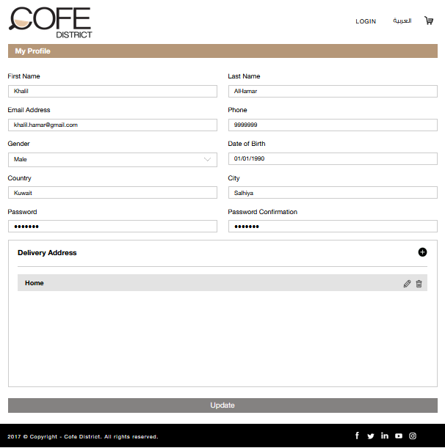

By clicking delivery address add button, we can add many types of address, which can be used for many process such as checkout.

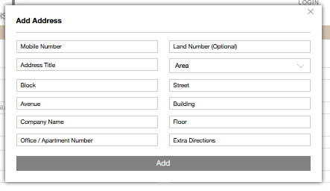

**2.3.3 Saved Addresses**

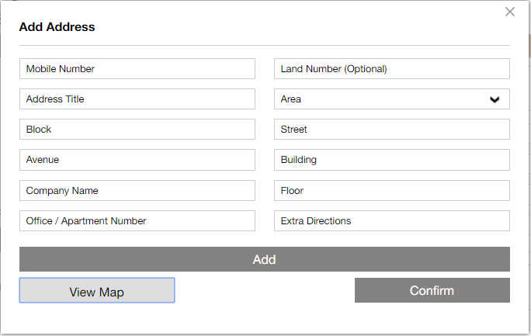

This allows the logged in users to select the delivery locations that are already added from his profile pages. The delivery locations will be as of 3 types

* + - * Apartment
      * House
      * Office

The logged in users can select any of the above that are already saved from his profile pages and then it will fill the delivery locations based on the area he/she saved. If there are multiple delivery locations based on the areas are saved by the user, then the area dropdown will list the areas that he saved for the delivery locations. From the list, he/she can select any area available and then the delivery location will be filled automatically.

If the user is guest user, then he/she have to enter all the required fields for delivery location and contact details.

There will be option to add new location for the logged in users and enter location for guest users, then a popup will be displayed and then it will load the current location of the user in Google map or user can select location manually from Google map. After selecting the location, the user needs to proceed to add the address in the popup. Following are fields for the delivery address

* + - First Name – will be filled automatically for registered users after login
    - Last Name - will be filled automatically for registered users after login
    - Delivery Area – Will be filled automatically after selecting the location from the Google map
    - Address Type (Apartment/House/Office)
    - Block (Optional)
    - Street
    - Avenue (Optional)
    - Building
    - Floor
    - Apartment Number
    - Mobile Number
    - Phone Number (Optional)

Additional Directions (Optional)

By clicking “View Map”, user can visually select their location and the location details will be loaded by default.

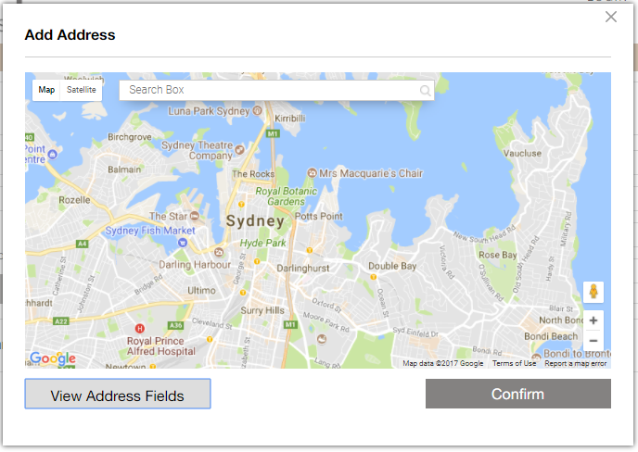

**Change Password**

This section allows the user to change his/her account password. For changing the password, the user needs to enter the below details

* + - * Current Password
      * New Password
      * Re-enter Password

When the user enter the above information and submit for password change, then the system will check the entered “Current Password” is correct or not. If it is wrong, the system will not allow the user to change his/her password and also will show the specific error message. The system will also validate the “New Password” and “Re-enter Password” values.

**2.3.4 Logout**

The User will be logged out from the dashboard

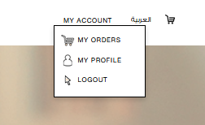

**2.4 Arabic/English**

Link to switch between User interface (Arabic or English)



**2.5 My Cart**

The Coffee cart will be available on side section of the menu listing page after the user order any Coffee items. This will have the summary of Coffee items that are currently added to Coffee cart by the user.

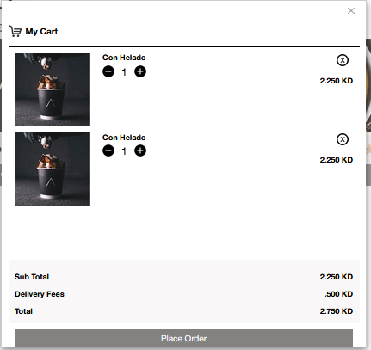

**3. Banner Section**

The banner images for the home page will be displayed here. The banners will be displayed in slider, and the slider will be auto sliding.

All banner images can be managed from the admin panel. Add, Edit and Delete of banners can be done from the admin panel by the Cofe District admin.

Following details of each banner can be managed from the admin panel

* + - * Banner Image
      * Display Order

The Cofe District admin can have additional option to disable/enable any banner image from the admin panel.

**3.1 Search by Location**

The page contains ‘Search by area’ and ‘search by coffee Shop’

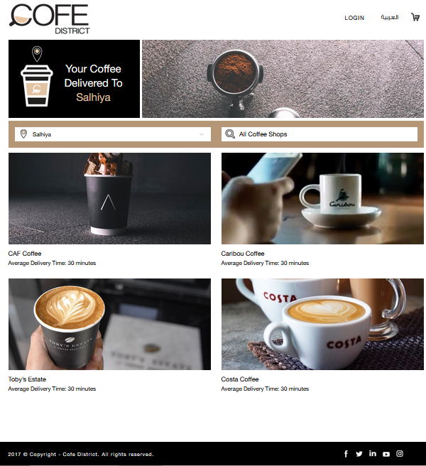

**3.1.1 Search Page with Search by location and Coffee Shop and List of All Coffee Shops**

This section allows the user to search for Coffee Shops in any specific area/location. There will be a dropdown list of areas that allows the user to search for the Coffee Shops in any specific area. Following are the options in the dropdown list

* + - * Area names list
        + Area 1
        + Area 2
        + Area 3

If the user selects any area’s name from the list, user will be redirected to the Coffee Shops listing page. The Coffee Shop list in the page will be filtered based on the selected area, and so that the Coffee Shops that are in the specific location will be only displayed in the page.

*Schedule your morning coffee!*

**

‘Delivery’ means It will be delivered by the Coffee shop to the customer.

Cofe Express means it will be a Pickup from the customer himself.

**3.1.2 Menu page with Categories, General Information, ratings & Products**

This section allows the user to search for Coffees in any specific Coffee Shops. There will be a space for typing Coffee Shops that allows the user to search for the Coffee items in any specific Coffee Shop. Following are the options in the dropdown list

If the user types any Coffee Shop’s name from the list, user will be redirected to the specific Coffee Shop’s details page.

This page will have the list of active Coffee Shops that are added by the Cofe District admin from the admin panel. There will be only one banner image for the page, and it will be static and so the Cofe District admin cannot change this section.

The page will be displayed with a thumbnail image. This page also has the “Search Coffee Shop” section to allow the users to search for Coffee Shops with any search keyword. For searching any Coffee Shop, user must enter any text in the text box.

If the user searches for any Coffee Shop, the Coffee Shop list will be updated with the search result. If there are no Coffee Shops that are matching with the keyword that the user entered, then the Coffee Shop listing section will display “No Coffee Shops found”.

The list of Coffee Shops will be ordered randomly on each page refresh. The list will have the following details for each Coffee Shop

* + - * Name
      * Order Number

*Rating*: - Rating of each Coffee Shop will be displayed in the list using stars. There will be 5 stars and this will be filled with respect to the rating of the specific Coffee Shop. Registered users can give ratings for all Coffee Shops after logged in to the system. Guest users don’t have permission to give ratings for Coffee Shops, for that he/she needs to register in the system. For giving rating, the registered user needs to click on the rating of any Coffee Shop and this will show a popup with the following details

Coffee Shop Thumbnail

Coffee Shop Name

Rating of the Coffee Shop in number

Blank stars (Maximum 5), for selecting the rating of the Coffee Shop

Clicking on each Coffee Shop details will redirect the user to the specific Coffee Shop’s details page.

Number of Coffee Shops listed will appear near to the “Coffee Shop” text

In the details page of the Coffee Shop, the user has to select the area of the Coffee Shop. The areas in which the selected Coffee Shop is available will be listed in the dropdown list.

First, the user have to select any particular area from the list and this will show the below details of the specific Coffee Shop in the selected area

* + - * Status (Open/Closed)
      * Working Hours (From HH:MM AM/PM to HH:MM AM/PM)
      * Delivery Time
      * Delivery Charges (In KD) / Service charges (In KD)
      * Payment Methods available for the Coffee Shop
      * Rating
      * Show Menu – Link to Menu detail page

User can view the menu of the specific Coffee Shop in the selected area only if the status is “Open”.

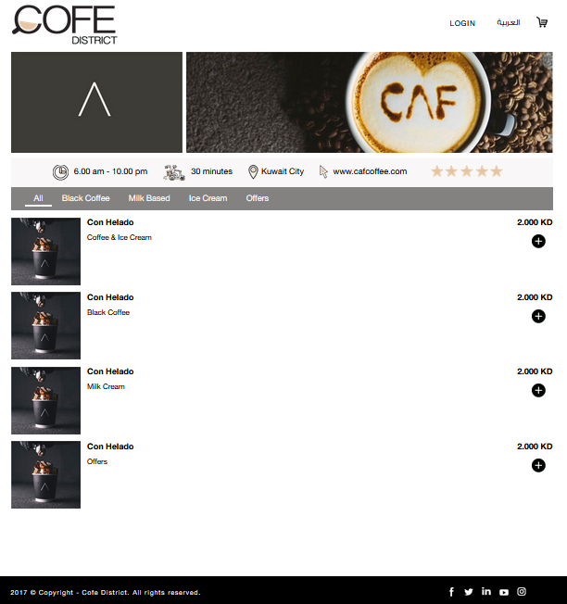

This page will list all the menu items available for the selected Coffee Shop (with respect to the selected area). Each menu items may have multiple Coffee items that are added from the admin panel by the Coffee Shop manager.

*Rate Service*

The registered users of the Cofe District website have the option to rate for any Coffee Shops.

The rating of Coffee Shops can be done from all the details pages. The registered users can rate from the Coffee Shop details page for Coffee Shops.

**3.1.3 Product Description page**

*Quantity*: - Each Coffee item in the menu will have the disable text that showing the quantity of the item. By default it will 1 and there will be an option for the user to increase or decrease quantity and then adding to his/her Coffee cart. The minimum quantity will be 1 for all Coffee items.

*Size*: - Item size is mandatory.

Guest and registered users can order the Coffee items from the page. There will be “Order Now” button to add the Coffee item to his/her Coffee cart. While ordering each Coffee item, the user’s Coffee cart will be updated and it will be displayed in the Coffee cart.

The Coffee Shop will add all cities and locations in admin panel that can cover; the user can show the list of these cities and locations provided by Coffee Shop admin.

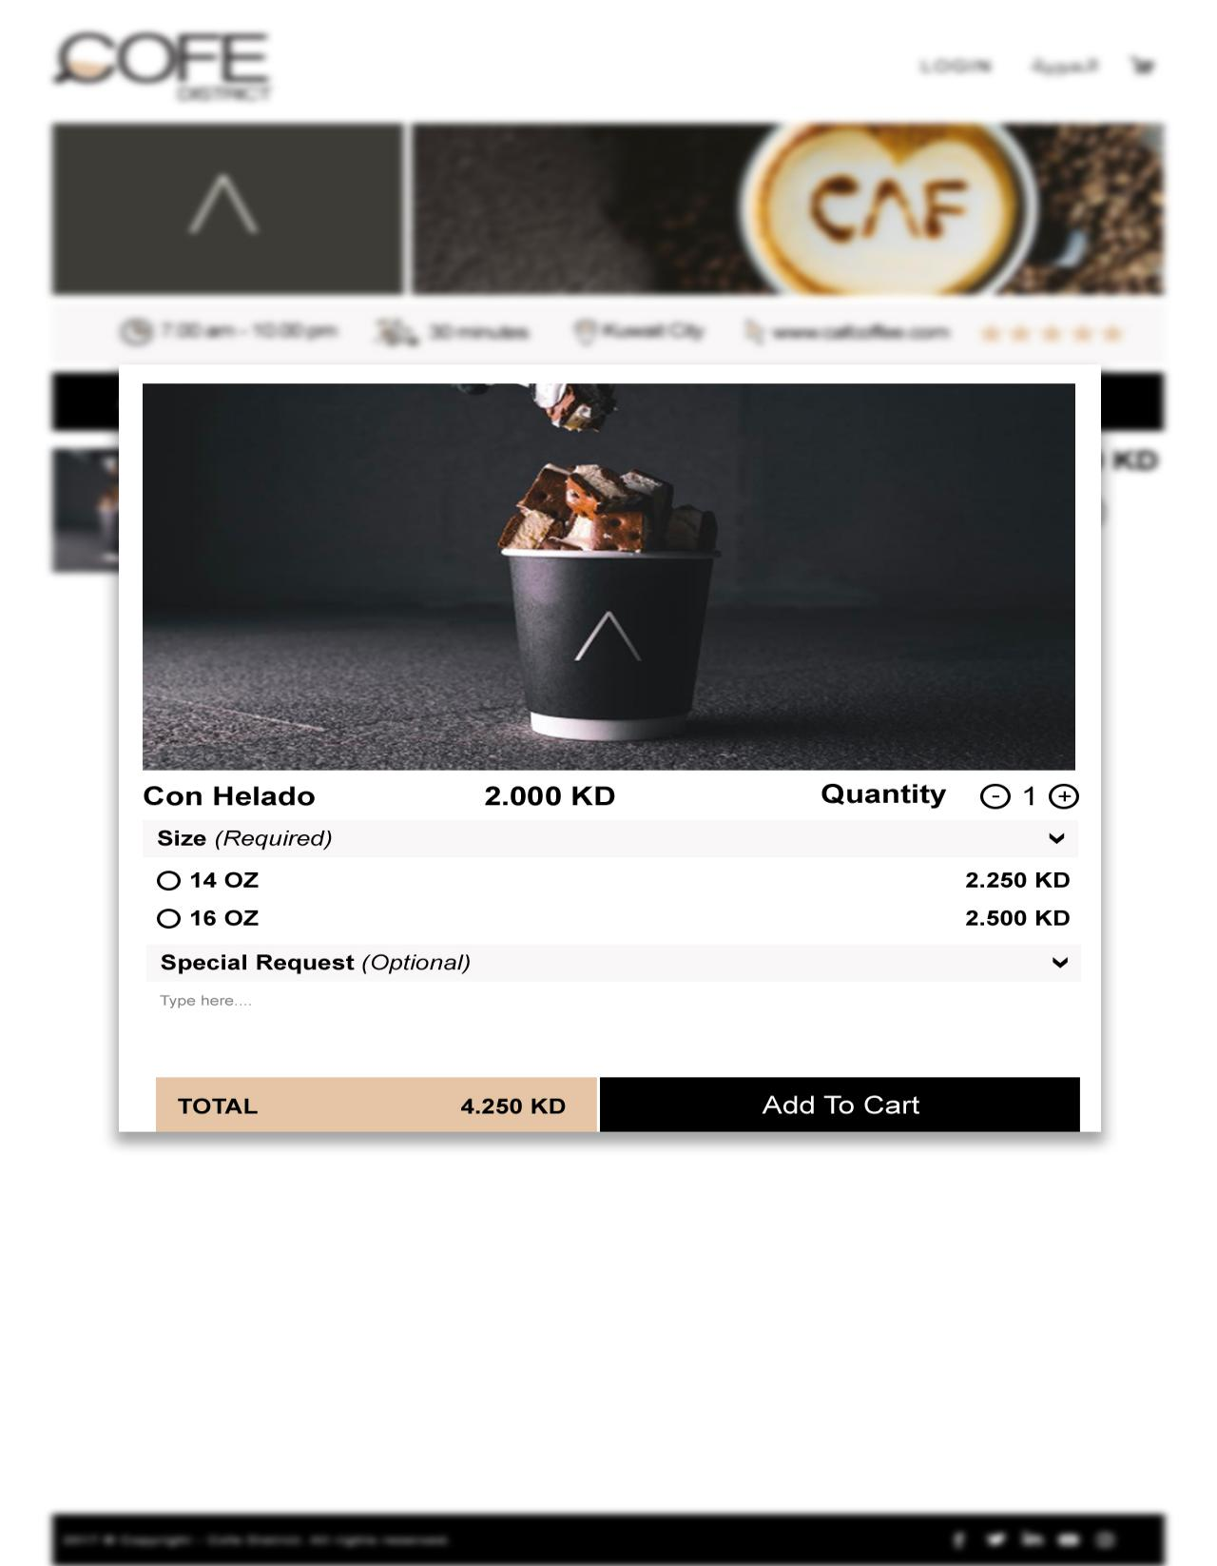

**3.1.4 My Cart Page**

The Coffee cart will be available on side section of the menu listing page after the user order any Coffee items. This will have the summary of Coffee items that are currently added to Coffee cart by the user.

The following will be in the Coffee cart details

* Thumbnail of each item
* Name of each item
* Total amount in KD for each item (Total + (Delivery charges or Service Charge )
* Remove option for each item
* Grand Total of the Coffee cart
* Checkout Button / Place Order

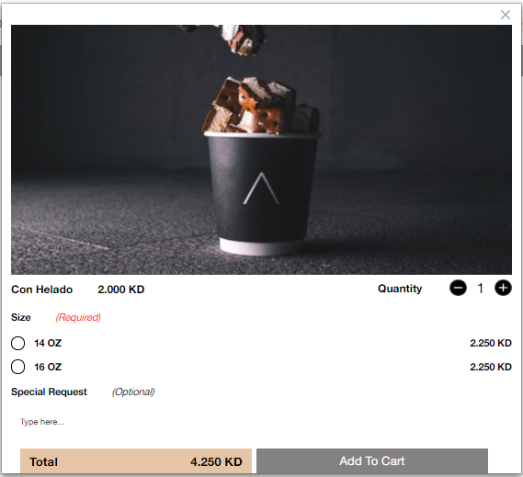

If any of the Coffee items for any particular Coffee Shop is not having the minimum order amount, then the “Checkout” button will not be visible to proceed to checkout.

**3.1.5 Checkout Page**

When the user clicking on the “Checkout”, the system will check whether the user is logged in or not. If the user is already logged in, then the user will be redirected to checkout page.

If the user is not logged in the system, then he will be redirected to a page where he can have the following options

* + - Login and proceed to checkout
      * Forget Password
    - Create New Account
    - Continue as Guest

*Login and proceed to checkout*: - This allows the user to login to his/her account with the user name and password and then the system will automatically proceed to checkout for completing the order.

*Create New Account*: - This allows the user to create a new account in Cofe District website as a customer user role. After creating the account, the system will automatically proceed to checkout page for completing the order. Customer registration details will be explained later.

Continue as Guest: - This allows the user to complete the order without creating any account in the Cofe District website. If the user selects this option, the user will be proceeded to checkout page and then he have to fill all the required fields in the delivery location and contact details.

The checkout page will have the following sections

* + - Delivery Information
    - Order Summary
    - Payment Methods
    - Place Order

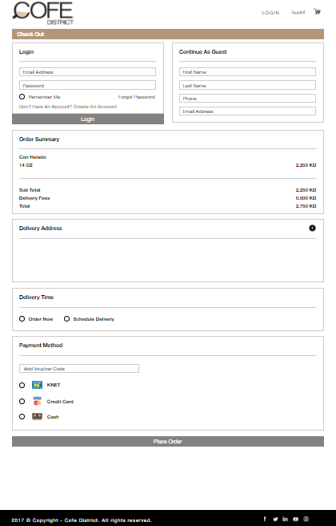

The delivery information can be added using below screen.



This allows the logged in users to select the delivery locations that are already added from his profile pages. The delivery locations will be as of 3 types

* + - * Apartment
      * House
      * Office

The logged in users can select any of the above that are already saved from his profile pages and then it will fill the delivery locations based on the area he/she saved. If there are multiple delivery locations based on the areas are saved by the user, then the area dropdown will list the areas that he saved for the delivery locations. From the list, he/she can select any area available and then the delivery location will be filled automatically.

If the user is guest user, then he/she have to enter all the required fields for delivery location and contact details.

There will be option to add new location for the logged in users and enter location for guest users, then a popup will be displayed and then it will load the current location of the user in Google map or user can select location manually from Google map. After selecting the location, the user needs to proceed to add the address in the popup. Following are fields for the delivery address

* + - First Name – will be filled automatically for registered users after login
    - Last Name - will be filled automatically for registered users after login
    - Delivery Area – Will be filled automatically after selecting the location from the Google map
    - Address Type (Apartment/House/Office)
    - Block (Optional)
    - Street
    - Avenue (Optional)
    - Building
    - Floor
    - Apartment Number
    - Mobile Number
    - Phone Number (Optional)

Additional Directions (Optional)

By clicking “View Map”, user can visually select their location and the location details will be loaded by default.



After selecting the delivery location, the user can proceed to order summary section.

*Payment Methods*

The user can select the type of payment from this section. There will be the following payment methods available for Cofe District

* + - * Cash On Delivery
      * KNET
      * VISA/MasterCard

Guest and Registered users can use all the above payment methods for completing the order in Cofe District.

If any of the Coffee Shop that the user has ordered Coffee items, that don’t have one of the payment methods above, then the specific payment method will not be available for the order.

After selecting any of the payment methods from the page, user can complete the order by clicking on the “Place order” button.

**3.1.5 Payment Gateway**

If the payment method is “Cash on Delivery”, then the order will be successfully completed at the same time and the user will be redirected to thank you page with all the details about the order. There will be print option for the user to print the details. The same details will be sending to the users email.

If the payment method is “KNET” or “VISA/MasterCard”, then the user will be redirected to the payment gateway page with secure connection (SSL). After completing successful payment, the order will be placed and the user will be redirected to the thank you page with all the details (order and transaction) about the order. If the payment is not successful or cancelled, the order will not be placed and the user will be redirected to the “payment not complete” page with the transaction details. There will be print option for the user to print the details. The same details will be sending to the users email.

All of the transaction details will be saved to the backend for keeping track of the transactions.

After a payment proceed is succeed, the user can track the order from two options:

“Track my order” this option for the logged in users, if a user clicked on this note will be redirected to the “Track My Order”.

4. About Us

A brief summary about Cofe District will be displayed here. This content can be edited from the admin panel by the Cofe District admin. This section includes the below

* + - * Description
      * Image

The content can be managed from admin panel.

**4.1 About us info**

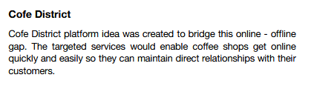

This page will have the details about the Cofe District website. There will be the following details in the page, image, title and detailed description about Cofe District

The title and detailed description of the page can be managed from the admin panel by the Cofe District Admin.

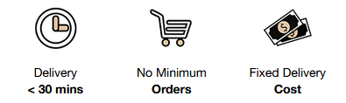

**4.2 Delivery<30 mins**

**4.3 No minimum orders**

**4.4 Fixed Delivery Cost**

**5. Order flow steps**

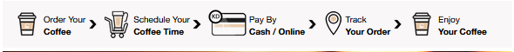

1. Browse Items
2. Add items to cart
3. View user cart (items/price)
4. Update/delete items in cart
5. Check User registration OR quick ordering (only name/phone/email)
6. Summarize order & Confirmation Order (Total price + Charges)
7. Type Promo Code (Optional)
8. Delivery Option
   * Order Now
   * Schedule (scheduled daily by their preferences. The user would choose the days and time to deliver the item)

**Note: The system would re-create the order in the coffee shop’s dashboard based on the that schedule**

1. Check out shopping cart (select Payment Method):
   * KNET
   * VISA / Master Card

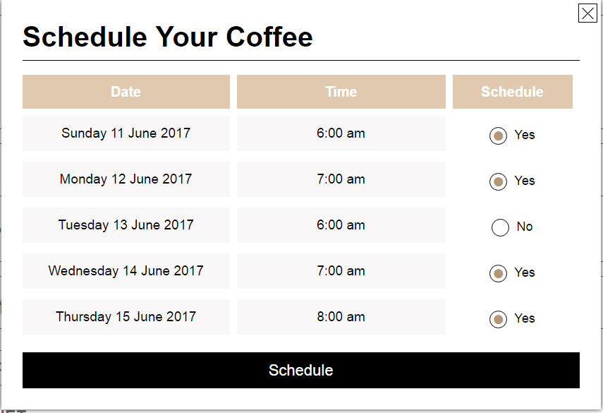

10. Redirect to Payment page (based on Payment Method)

11. View order receipt / print

12. Thanks Page /Rating

**6. Advertisement Banners (1 Main and 3 Subs)**

This section can be managed by admin panel. Admin will be able to set an expiry date for each advertisement and also set a time length for each advertisement to be displayed. The admin will also be able to edit or delete an advertisement from the system.



**6.1 Main Banner – Slideshow**



This section can be managed by admin panel. Admin will be able to set an expiry date for each advertisement and also set a time length for each advertisement to be displayed. The admin will also be able to edit or delete an advertisement from the system.

**6.2 Sub ads**



This section can be managed by admin panel. Admin will be able to set an expiry date for each advertisement and also set a time length for each advertisement to be displayed. The admin will also be able to edit or delete an advertisement from the system.

**6.3Add your Coffee shop form pop up**



This section can be managed by admin panel. Admin will be able to set an expiry date for each advertisement and also set a time length for each advertisement to be displayed. The admin will also be able to edit or delete an advertisement from the system.

New coffee shops add request will be done using below form.

Below fields are required:-

* + Coffee shop name
  + Representative name
  + Phone
  + Email address
  + Website
  + Instagram account

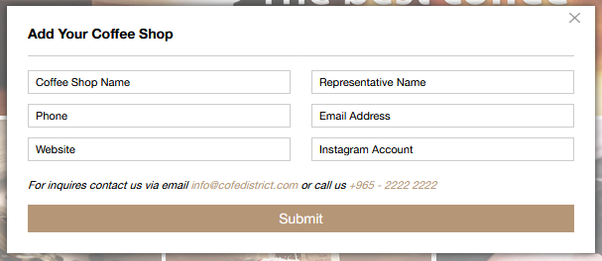

**7. Footer**

The footer contains Mobile Application links, Social Links, Static page Links, Cofe Club areas and contact information.

**7.1 Browse**

**7.1.1 Home**

This link will be redirected to home page.

**7.1.2 About us**

A brief summary about Cofe district will be displayed here. This content can be edited from the admin panel. This section includes the below

* + - * Title
      * Descriptions
      * Video & Images

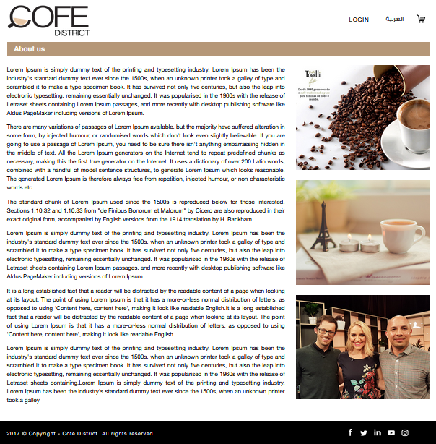

**7.1.3 Careers**

The job seekers will upload their CVs with their details. The same will be updated as a row in the Cofe district admin panel.

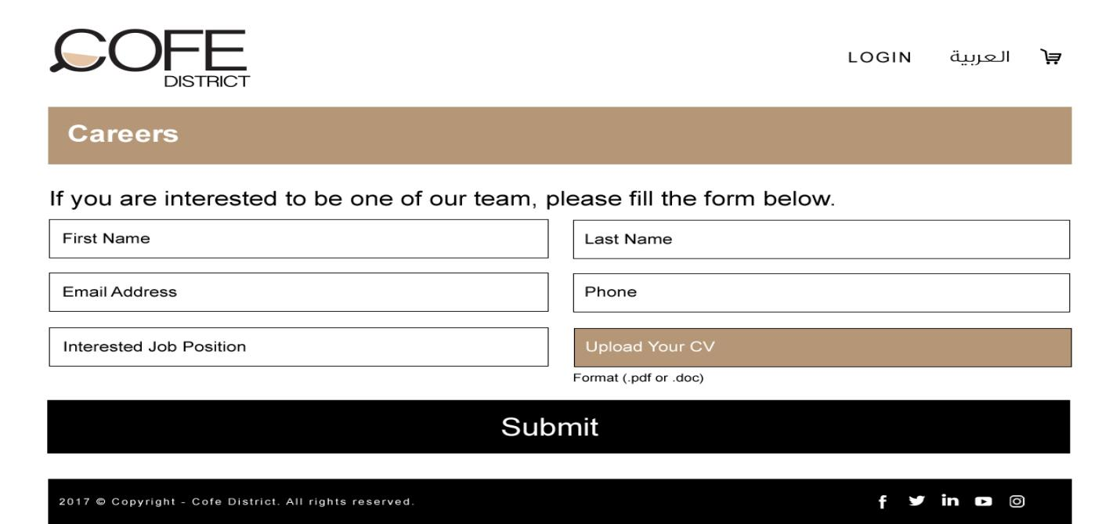

Below details are mandatory:-

* First Name //Text field
* Last Name //Text field
* Email address //Text field with Email validation
* Phone //Text field with Phone validation
* Interested Job position //Text field
* Upload CV //Users can upload their CV with pdf/doc type

**7.1.4 Media**

The latest media release will be displayed in this section.

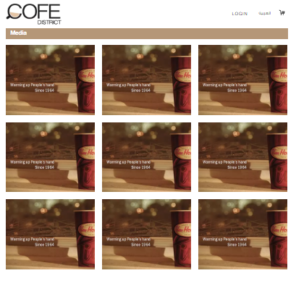

When we click on a media item, the details of the media will be displayed as like below.

The page will have a media sliding banner and media description.



**7.1.5 Cofe Blog**

Search Bar with Blogger or date, with Become Blogger option (Pop up form) and list of Blogs.

The registered customers can view the latest articles from Cofe District and read the full article and share it through social media

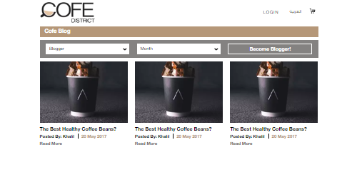

When a user clicks on Become a Blogger, two scenarios are observed:-

* If the user is already Signed-in, by clicking on the “Become a Blogger” button, the request will automatically with the User details be sent to the Cofe District Admin.
* If the user is not signed in it will show a pop form asking for the below user details:-
* Name
* Email
* Phone

After submitting the above request, details will be sent to the Admin.

The Blogger will send the Blogs to the Cofe District Admin through separate emails and after approval it will be posted by the Cofe District Admin through the Admin panel.

**7.1.5.1 Cofe Blog article with Image //Share on social media**

The page will have blog related images and media description.

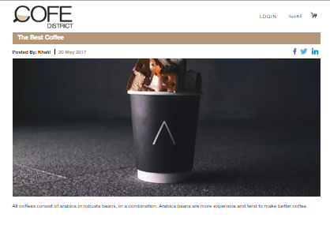

Any user can view the Blogs and share it using the below Social media applications:-

* Facebook
* Twitter
* Linkedin

**7.1.6 Contact us**

* + Users will be able to fill-up his information in the fields such as : (First Name, Last Name, Email address, Phone, Message)
  + Then press submit button to email and CMS(Data will be saved in the CMS.)

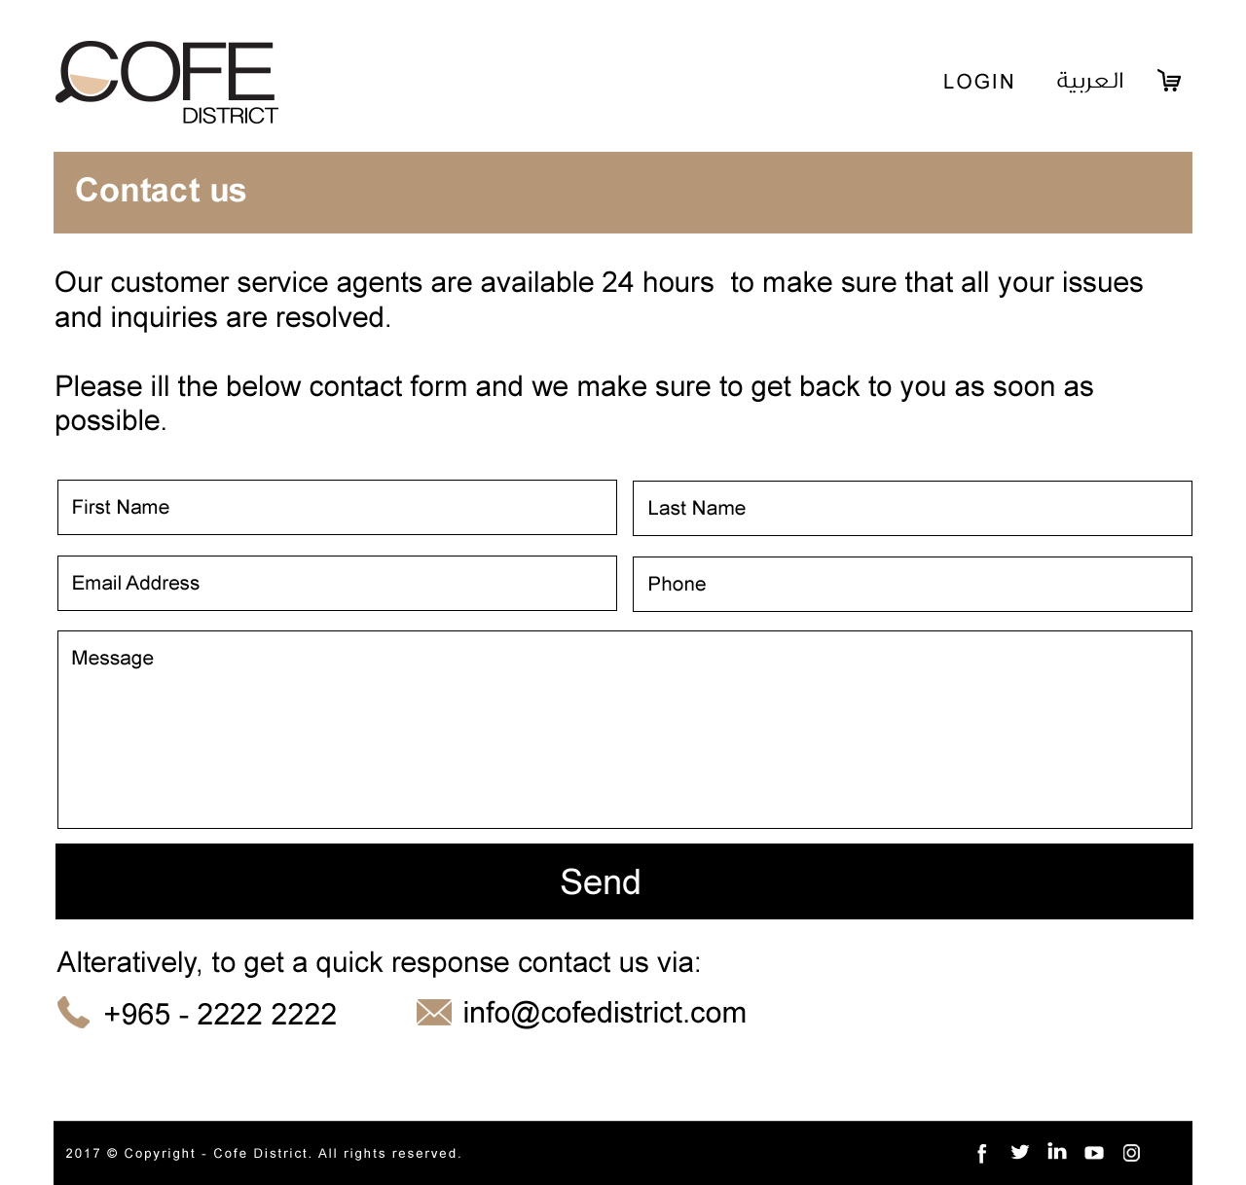

**7.2 Orders**

**7.2.1 My Profile**

By default the profile page will display the account dashboard and will have his personal information as below

* First name
* Last name
* Email
* Phone
* Gender
* DOB
* Country
* City
* Password
* Confirm password
* Delivery Address Add and List

From the account dashboard, the user can view all the personal information of his account.



By clicking delivery address add button, we can add many types of addresses, which can be used for many processes such as checkout etc.



**7.2.2 My Orders**

This section will display the order history of the specific user. The order will be listed in accordion style and there will be option for the user to select the page size to view the list. The page size will be 10, 50, 100, 200 and the list will be with pagination.

The list will show the following details by default

* + - * Coffee Shop name
      * Order No.
      * Date & Time
      * “Re-order”
      * Receipt

Clicking on each order will show the full details about the order, and this will have the following details

* + - * Details of each ordered dish
        + Coffee Shop Name

Item Name

Quantity

Unit Price

Grand Total

**7.2.2.1 Current Orders**

Current orders section displays the latest orders for different Coffee Shops. This section will be displayed as a slider, so that the latest orders will be displayed randomly in a specific time interval.

The current orders will be listed as like below



**7.2.2.2 Completed Orders**

All finished orders section displays the all the completed orders from different Coffee Shops. This section will be displayed as a slider, so that the latest orders will be displayed randomly in a specific time interval.

All the finished orders will be listed as like below. Each list will have a summary and a receipt.



**7.2.3 Order Summary**

This section will have the details of each Coffee item he/she ordered as below

* Payment methods available
* Menu
  + Item name
  + Quantity
  + Unit Price (In KD)
  + Total Price (In KD)
  + Special request (Text area)
  + Remove button – For removing items from the order



The user can select the delivery time as below

* + Now
  + User can select date till the post order date that accepts the Coffee Shop
  + If today is Sunday and time is 12:30 PM and Coffee Shop post order date accepts 3 days then the list will have date and time from Sunday 01:45 PM to Tuesday 12:30 PM
  + List of date time will be for each 15 min time interval (Sunday 12:30, Sunday 12:45, Sunday 01:00 etc.).

Now: - This allows the user to place order for now.

If Coffee items from multiple Coffee Shops are selected then the shortest of the post order day Coffee Shops will be taken for the pre-order for later.

**7.2.4 FAQs (Frequently Asked Questions)**

This section can be managed by admin panel, it contains questions & answers.

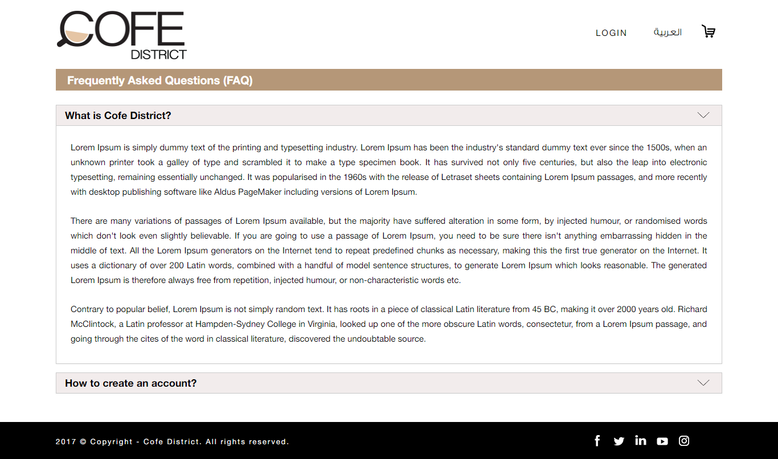

**7.2.5 Privacy Policy**

This page will have the privacy policy details of Cofe District website. There will be the following details in the page

* + - * Title
      * Privacy policy details

The title and privacy policy details of the page can be managed from the admin panel by the Cofe District Admin.

The policy includes different Cofe district policies such as Profiles policy and security policies.

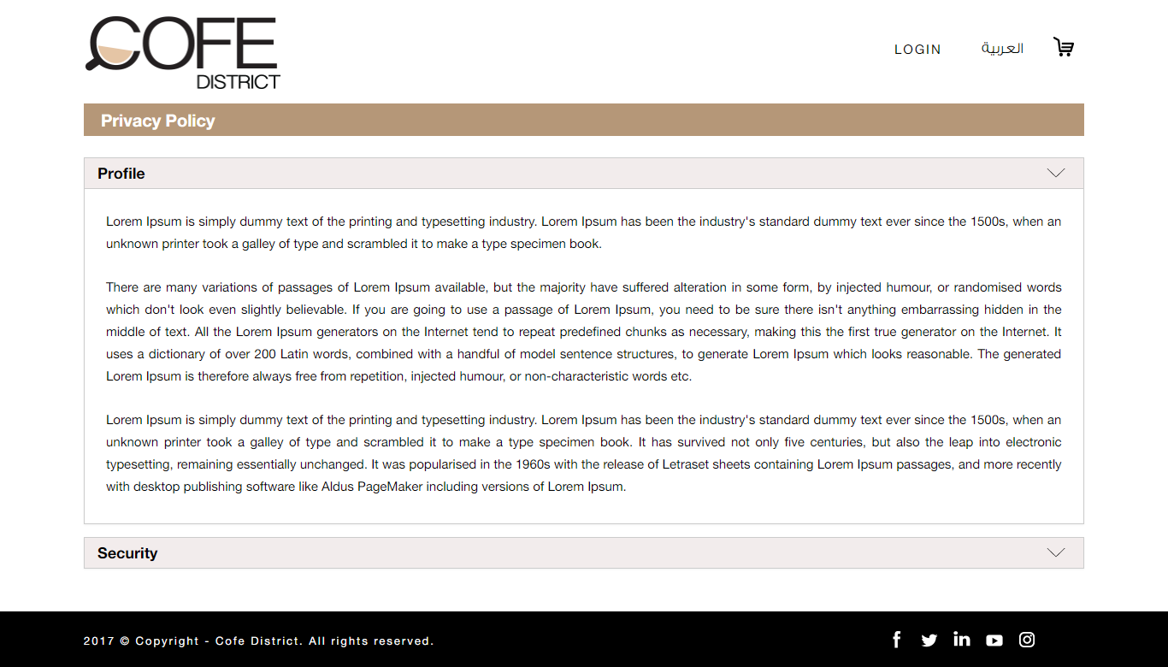

**7.2.5.1 Profiles**

Content can be managed through the Admin panel.

**7.2.5.2 Security**

Content can be managed through the Admin panel.

**7.2.6 Terms & Conditions**

This page will have the details of the terms & conditions of the Cofe District website. There will be the following details in the page

1. Order Cancellations

2. Licenses

The title and Terms & Conditions details of the page can be managed from the admin panel by the Cofe District Admin.

The condition includes different cofe district conditions such as Order Cancellations and Licenses.

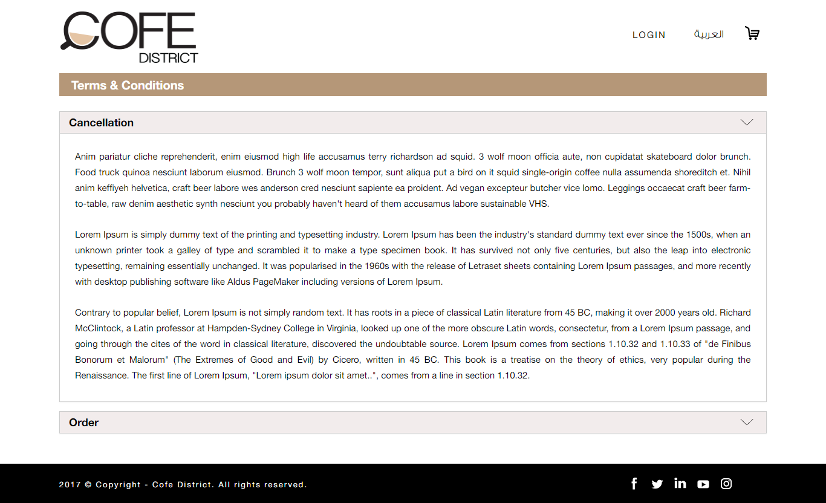

**7.2.6.1 Order Cancellations**

Content can be managed through the Admin panel.

**7.2.6.2 Licenses**

Content can be managed through the Admin panel.

**7.3 Cofe Club**

**7.3.1 My Gift cards**

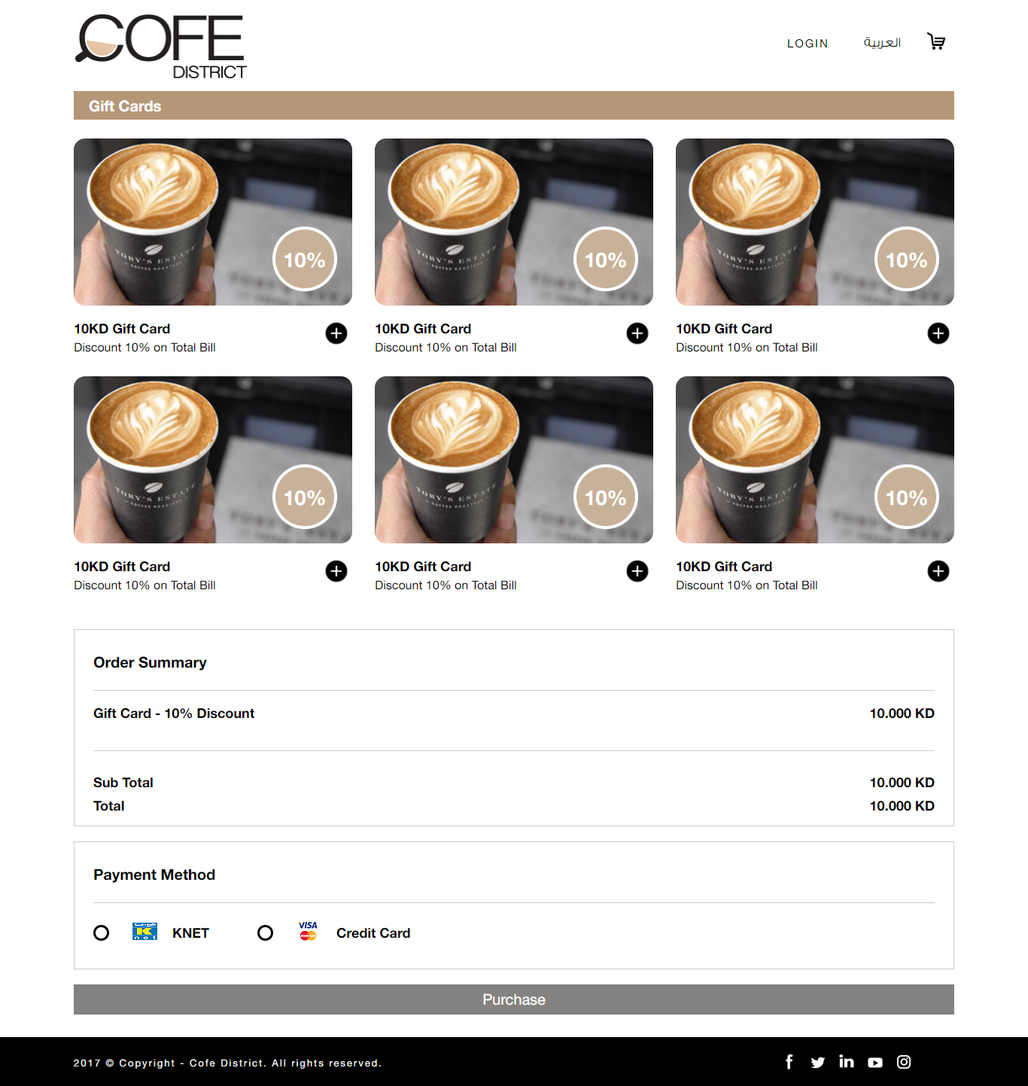

It will display a list of Gift cards with title and discount details. After you add a Gift card, it will display the Order summary & Payment gateway.

**7.3.1.1 Gift Cards**

Gift card with Send to friend form pop up & View Receipt. This section can be managed by admin panel. Users can buy any gift card and pay via KNET or Credit Card. Confirmation message will appear and receipt will be sent by email.

Different kind of Gift Card, each gift card would have fixed amount and picture (Example: KD 5, KD 10, KD 20, etc.)

**Note:** Once the users buy a gift card, the system would generate unique number to be use only once in the cart

**7.3.2 Offers**

Users can see all the latest offers offered from different Coffee Shops. When any user clicks on any image, it will be linked to the related Coffee Shop Offers tab. This section can be managed by admin panel.

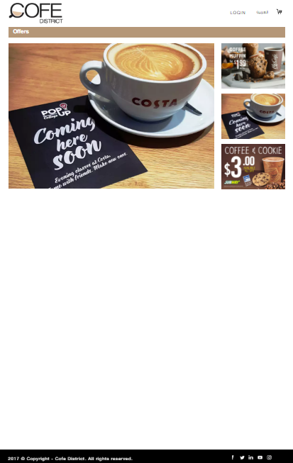

**7.3.3 Catering**

Users can request to fill a form for catering from the offered Coffee Shops. An agent will contact the user for more information.

All the catering requests from the customers will be displayed at the admin panel. Also he/she can Change the status of each request.

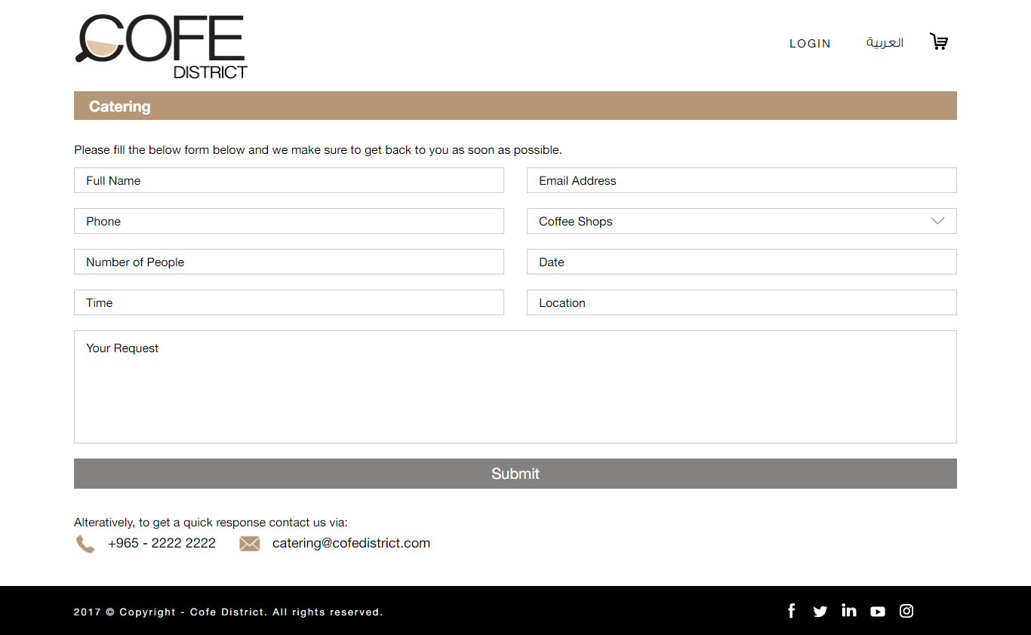

Below are the details:-

* + Full Name //Text field
  + Email address //Text field with Email validation
  + Phone //Text field with Phone validation
  + Coffee Shops //Dropdown, It will take the details from the Admin panel.
  + Time //Text field
  + Location //Text field
  + Your Request //Text area

**7.4 Contact**

This page will have contact form that allows the user to send email to the Cofe District admin to ask about any enquiries or information. The email will be forwarded to the Cofe District admin’s email and this email id can be managed from the admin panel by Cofe District admin.

There will be following fields in the contact form,

* + - * First Name // Textfield
      * Last Name // Textfield
      * Email Address // Textfield with Email validation
      * Phone // Textfield with Phone validation
      * Message //Textarea

After submitting the form, the submitted details will be forwarded to Cofe District admin’s email and a confirmation email will be send to the contacted persons email id.

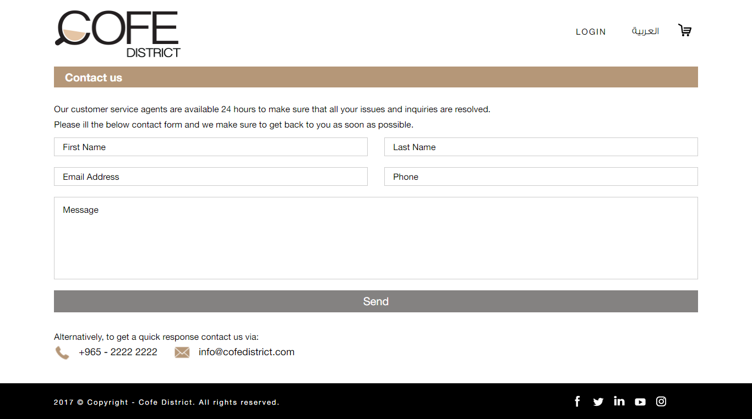

**7.5 Download Android & IOS icons**

By clicking this icon you will be redirected to the download centers**.**

**7.6 Copyright info**

**7.7 Social Media icons**

By clicking these icons you will be redirected to the corresponding Social media links**.**

**7.7.1 Face book**

**7.7.2 Twitter**

**7.7.3 LinkedIn**

**7.7.4 YouTube**

**7.7.5 Instagram**

1. Administration Section

The administration section allows the following admin users to manage the different components in the Cofe District E-commerce website

* + - * Super Admin
      * Coffee Shop Admin

These users have different authorizations and privileges to the administration sections.

## 4.1 Super Admin

Super admin will be the master admin account in the Cofe District website. Cofe District admin will be the super admin for the system. The following sections can be managed by the super admin

* + - * Order Management
      * Coffee Shop Management
        + Add Coffee Shop
        + Search Coffee Shop

Status

Open

Closed

Busy

Hidden

Coffee Shop Name

* + - * + Coffee Shop List

Sort Order

Thumbnail Image & Title

Accepted payment types

Brach details

Number of branches

Number of open branches

Number of closed branches

Number of busy branches

Number of hidden branches

Actions

Delivery Menu

Branches

Status

Manage

Edit Coffee Shop

Edit details

Manage Drivers

Manage Branch

Manage Menu

* + - * New Coffee Shops
      * Area Management
      * User Management
      * Resource Strings
      * Home Banner Management
      * Content Management
      * Advertisement Banner Management
      * Notification Management
      * Reports

### 4.1.1 Order Management

Super admin can manage the orders for different Coffee Shops from this section. These orders will be listed in the page, and the super admin can use the following filters to view the filtered order lists

* + - * + Coffee Shop Name

All

List of Coffee Shops

* + - * + User Type

All

Registered Users

Guest Users

* + - * + Transaction Type

All

KNET

Cash On Delivery

VISA/MasterCard

* + - * + From Date
        + To Date
        + Status

The list of orders will be generated with respect to the filter options the Super admin have selected. The list will have the following details

* + - * + Transaction Id
        + Order Id
        + Email
        + User Type
        + Status
        + Payment Type
        + View Details
        + Assign To Driver/Reassign to driver

The list will have the above details and “View more” will show the full details of the order.

Assign to Driver/ Reassign to driver: - This will allow the Super admin to assign or re assign any specific order to a specific driver. For not assigned orders, this will display “Assign to driver” and after assigning the order to any driver will show option as “Reassign to driver”.

Clicking on the above option will show the below details to the Super admin

* + - * + Order summary
        + Delivery location in Google map
        + Ordered branch details and location in Google map
        + Drivers list who are near to the ordered branch (The driver who are nearest to the branch will be on the top of the list)

Clicking on the driver names in the list will show the following details in a popup

* + - * + Driver details
        + Current location of driver in Google map
        + Drivers mobile battery status
        + Total orders delivered for today
        + Total orders in hand for today
        + History of orders
        + Assign/Reassign

History of orders: - The super admin can view the history of orders for the specific driver. There will be “from” and “to” date selection to view the delivered orders for the specific date.

The super admin can see the above details of the driver and then he can assign or reassign the order to the driver.

Super admin can assign Cofe District drivers or drivers of the specific Coffee Shops for delivering any order. Coffee Shops should pay extra payments to Cofe District if the order is assigning to Cofe District driver.

If the super admin assign an order to a driver, then the driver will be notified. Then the driver can accept/reject the assigned order. If the driver accepts the order, then the order delivery will be assigned to the specific driver.

If the driver rejects the order or the driver is not available then the Super admin can reassign the same order to another driver. In this case the first driver will be released from this order and the new driver will be assigned for this order.

### 4.1.2 Coffee Shop Management

This will allows the super admin to manage the Coffee Shops in the Cofe District website. There will be search option for the super admin to search for any specific Coffee Shops in the Cofe District website. Following are the search options available for the super admin

* + - * + Status

Open

Closed

Busy

Hidden

* + - * + Coffee Shop Name (English/Arabic)

Following sections can be managed from the Coffee Shop management

Create new Coffee Shops

This allows the super admin to create new Coffee Shops in the Cofe District website. The super admin can create unlimited number of Coffee Shops Cofe District website.

For creating Coffee Shops, the super admin have to provide detail for both English and Arabic. Following are the details for creating new Coffee Shops

* + - * + Coffee Shop Status
        + Coffee Shop Name (English)
        + Coffee Shop Name (Arabic)
        + Description (English)
        + Description (Arabic)
        + Summary (English)
        + Summary (Arabic)
        + URL
        + Coffee Shop Thumbnail
        + Payment Methods

KNET + Textbox for Commission Amount

COD + Textbox for Commission Amount

VISA/MasterCard + Textbox for Commission Amount

* + - * + Post Date Order (Number of days – for ordering in advance)
        + Commission Type

Percentage

Fixed

* + - * + Minimum Order Amount
        + Discount Type

Percentage

Fixed

* + - * + Discount
        + Enable/Disable push notifications

Above are the details that are required to create a new Coffee Shop in Cofe District website. After creating the Coffee Shop, super admin can manage the following details for the new Coffee Shop.

* + - * + Drivers
        + Branches
        + Delivery Menu

Edit Coffee Shop

Super admin can modify existing details of any specific Coffee Shop using “Edit Coffee Shop” option. Following are the details that the super admin can manage for each Coffee Shop

* + - * + Coffee Shop Status
        + Coffee Shop Name (English)
        + Coffee Shop Name (Arabic)
        + Description (English)
        + Description (Arabic)
        + Summary (English)
        + Summary (Arabic)
        + URL
        + Coffee Shop Thumbnail
        + Payment Methods

KNET + Textbox for Commission Amount

COD + Textbox for Commission Amount

VISA/MasterCard + Textbox for Commission Amount

* + - * + Post Date Order (Number of days – for ordering in advance)
        + Commission Type

Percentage

Fixed

* + - * + Minimum Order Amount
        + Discount Type

Percentage

Fixed

* + - * + Discount
        + Enable/Disable push notifications

From the edit Coffee Shop page, the super admin can also the following sections

* + - * + Drivers
        + Branches
        + Delivery Menu

Delivery Menu Management

This section allows the super admin to manage the delivery menu for any specific Coffee Shop. Following are the details that are required for adding/editing a delivery menu

* + - * + Menu Name (English)
        + Menu Name (Arabic)
        + Description (English)
        + Description (Arabic)
        + Status

Hide

Show

The Coffee items will be added under any specific menu for the Coffee Shops. Status of the delivery menu will allow the super admin to show or hide the delivery menu from the Coffee Shop details page.

Super admin will have the option to edit/delete any existing delivery menu for any Coffee Shop.

Menu of a Coffee Shop will have the multiple numbers of sections. Each section will have multiple Coffee items.

There will be “View full menu” and “View section” for menus in each Coffee Shop.

**View Full Menu**: - This will have the details of all the sections and all the Coffee items under each section. This will have the following details

* + - * + Section A

Item 1

Name (English)

Price

Name (Arabic)

Thumbnail Image

Item 2

Name (English)

Price

Name (Arabic)

Thumbnail Image

Item 3

Name (English)

Price

Name (Arabic)

Thumbnail Image

* + - * + Section B

Item 4

Name (English)

Price

Name (Arabic)

Thumbnail Image

Item 5

Name (English)

Price

Name (Arabic)

Thumbnail Image

**View Section**: - This will show the list of sections that are added for a Coffee Shop menu. This list will have the following details

* + - * + Section Name (English)
        + Section Name (Arabic)
        + Status
        + Edit Section
        + View Menu Item

**Edit Section**: - Edit Section allows the user to edit the existing details of a specific section. Following details of a section can be edit by the super admin

* + - * + Section Name (English)
        + Section Name (Arabic)
        + Description (English)
        + Description (Arabic)
        + Status (Hide/Show)

**View Menu Item**: - This will show the list of menu items (Coffee items) for the specific section. There will be a list of menu items for the specific section, and the details for each menu item in the list are as below

* + - * + Menu Item Name (English & Arabic)
        + Price
        + Status
        + Thumbnail
        + Edit Item
        + Category Choice – for adding special choice Coffee items related to the selected menu item

Edit any specific menu item will allow the super admin to edit the following detail of the menu item

* + - * + Menu Name (English)
        + Menu Name (Arabic)
        + Description (English)
        + Description (Arabic)
        + Price
        + Discount
        + Thumbnail
        + Available From
        + Available To
        + Menu Section
        + Status

Super admin can modify any details of the above and can save the details.

There will be “Add Menu item” option for the super admin to create new menu items for any specific sections. Following are the details that are needed for creating a new menu item

* + - * + Menu Name (English)
        + Menu Name (Arabic)
        + Description (English)
        + Description (Arabic)
        + Price
        + Discount
        + Thumbnail
        + Available From
        + Available To
        + Menu Section
        + Status

**Category Choice**: - This will allows the super admin to manage the special choices for the specific menu item. When a menu item have the category choices, then these category choice items will be displayed along with the menu item in the menu details page. The category choice item will have the following

* + - * + Create category choice
        + List of category choices

Edit

Choice

*Create category choice* will allow the super admin to create new category choice for the menu item. Following detail are required for creating new category choice

* + - * + Name (English)
        + Name (Arabic)
        + Minimum items – Minimum order quantity
        + Maximum items – Maximum order quantity

*Editing category choice* allows the super admin to modify any existing category choices, following details can be modified

* + - * + Name (English)
        + Name (Arabic)
        + Minimum items – Minimum order quantity
        + Maximum items – Maximum order quantity

Choices will allow the super admin to manage the Coffee item choices for the specific category choice. Following will be in the choices

* + - * + Add Menu Item Choice
        + List of choices

Name

Price

Available (From and To)

Thumbnail Image

Edit Item

For creating choice for any category choice, following detail are needed

* + - * + Name(English)
        + Name(Arabic)
        + Description(English)
        + Description(Arabic)
        + Status
        + Price
        + Discount
        + Thumbnail
        + Available From
        + Available To

While editing any category choice, following details can be managed by the super admin

* + - * + Name(English)
        + Name(Arabic)
        + Description(English)
        + Description(Arabic)
        + Status
        + Price
        + Discount
        + Thumbnail
        + Available From
        + Available To

There will be option “Add Section” for the super admin to create new sections for the menu in the view section page. Super admin can create new section with providing the following details

* + - * + Section Name (English)
        + Section Name (Arabic)
        + Description (English)
        + Description (Arabic)
        + Status (Hide/Show)

Branches Management

This allows the super admin to manage the braches for any specific Coffee Shop. Super admin can create braches from this page, using “Add Branch” link. For adding a branch for a specific Coffee Shop, super admin have to provide the following details

* + - * + Area Name

List of areas

* + - * + Description(English)
        + Description(Arabic)
        + Phone
        + Fax
        + Fax Backup
        + Routing Method

Fax

Application

Phone

Email

* + - * + Location selector using Google map (Will set the latitude and longitude details from Google map)

Latitude

Longitude

Super admin can create branches for Coffee Shops using the above details and there will be location selection option for the super admin to select the exact location of the branch on Google map. Whenever the super admin selects the Google map location, the latitude and longitude details will be fetched from the Google map and the super admin can save the new branch details.

There will be list of branches for the Coffee Shop in the branch management page and it will have the following details of each branch

* + - * + Branch Id
        + Branch Name

Number of covering areas

Number of open branches

Number of closed branches

Number of busy branches

* + - * + Status (Hide/Show)
        + Manage Coverage Areas
        + Edit Branch
        + Delete

**Status**: - The super admin can set hide/show status for any specific branch.

Manage Coverage Areas

This will allows the Coffee Shop admin to manage the coverage areas for any specific Coffee Shop’s branch.

By default, this will show the list of coverage areas that area added for the specific branch. This will have the following detail

* + - * + Coverage Area Name (English & Arabic)
        + Details

Delivery Charges / Service Charge

Minimum Amount

Delivery Time

Status

* + - * + Operation Hours
        + Edit Details

Coffee Shop admin can edit the above information using “Edit Details” for any specific coverage area.

**Edit Coverage Area**: - This will allows the super admin to modify the existing details of any branch. Following are the details that the Coffee Shop admin can manage

* + - * + Coverage Area Name

List of area names

* + - * + Details

Delivery Charges / Service Charge

Minimum Amount

Delivery Time

Status

* + - * + Operation Hours

Sunday - Shift 1 (From – To), Shift 2 (From – To)

Monday - Shift 1 (From – To), Shift 2 (From – To)

Tuesday - Shift 1 (From – To), Shift 2 (From – To)

Wednesday - Shift 1 (From – To), Shift 2 (From – To)

Thursday - Shift 1 (From – To), Shift 2 (From – To)

Friday - Shift 1 (From – To), Shift 2 (From – To)

Saturday - Shift 1 (From – To), Shift 2 (From – To)

The delivery charges, Service Charge and Cofe District charges will be calculated with the amount for orders to the specific area from the specific Coffee Shop’s branch.

Website users cannot select any specific area while the coverage area’s status is not open.

There will be option “Add coverage area” in the “manage coverage area” page. This will allows the Coffee Shop admin to add coverage areas for any specific Coffee Shop branch. Following are the details required for adding new coverage area

* + - * + Coverage Area Name

List of area names

* + - * + Details

Delivery Charges / Service Charge

Cofe District Charge

Minimum Amount

Delivery Time

Status

* + - * + Operation Hours

Sunday - Shift 1 (From – To), Shift 2 (From – To)

Monday - Shift 1 (From – To), Shift 2 (From – To)

Tuesday - Shift 1 (From – To), Shift 2 (From – To)

Wednesday - Shift 1 (From – To), Shift 2 (From – To)

Thursday - Shift 1 (From – To), Shift 2 (From – To)

Friday - Shift 1 (From – To), Shift 2 (From – To)

Saturday - Shift 1 (From – To), Shift 2 (From – To)

Edit Branch

This will allows the super admin to edit the following details of any specific Coffee Shop branch

* + - * + Area Name

List of areas

* + - * + Description(English)
        + Description(Arabic)
        + Phone
        + Fax
        + Fax Backup
        + Routing Method

Fax

Application

Phone

Email

* + - * + Location selector using Google map (Will set the latitude and longitude details from Google map)

Latitude

Longitude

Super admin can edit the above details of branches. There will be location selection option for the super admin to select the exact location of the branch on Google map. Whenever the super admin selects the Google map location, the latitude and longitude details will be fetched from the Google map and the super admin can update the branch details.

### 4.1.3 New Coffee Shops

This page will show the list of Coffee Shops that recently added in the Cofe District website. The Coffee Shops that added recently and lesser than one month will be displayed in this page.

The functionalities and details will be same as “Coffee Shop Management”.

### 4.1.4 Area Management

This page allows the super admin to manage the areas for the Cofe District website. The super admin can add/edit or delete any specific area.

Following are the details required for add/edit any area

* + - * + Area Name (English)
        + Area Name (Arabic)

This page will also show the list of areas that already exist in the Cofe District website. Following are the details displayed in the list

* + - * + Area Name (English)
        + Area Name (Arabic)

### 4.1.5 User Management

This page allows the super admin to manage the user accounts for Cofe District website and mobile applications.

Super admin can manage following types of user roles

* + - Super Admin
    - Coffee Shop Admin
    - Driver
    - Customer

Following are the details of each user role

Super Admin

* + - Admin with full control over the Cofe District admin panel and mobile applications.
    - These admins will have full privileges in the Cofe District admin panel and mobile applications.
    - These admins can manage orders, Coffee Shops, pages, areas, admin users, registered users etc.
    - These admins will be for Cofe District.

Following will be the fields..

* + - * User Name
      * Password
      * Confirm Password
      * Email
      * First Name
      * Last Name
      * Mobile Number
      * User Role

Coffee Shop Admin

* + - These admins are the admin users for specific Coffee Shops.
    - Multiple Coffee Shop admins can be assigned for a Coffee Shop.
    - Multiple Coffee Shops can be assigned to a Coffee Shop admin.
    - Coffee Shop admin will only have access to the specific Coffee Shop and the orders specific to the Coffee Shop.
    - Super admin will create and assign Coffee Shop admins for different Coffee Shops.

Following will be the fields..

* + - * User Name
      * Password
      * Confirm Password
      * Email
      * First Name
      * Last Name
      * Mobile Number
      * User Role
      * Coffee Shops
      * List of Coffee Shops to assign

Driver

* + - These users are for delivering the orders of customers from the specific Coffee Shops branches.
    - Super admin can create drivers for Cofe District and also for the Coffee Shops separately.
    - Driver users are for mobile applications.
    - Coffee Shops can use their drivers and also Cofe District drivers for delivering any order.
    - Coffee Shops should pay extra payments for assigning Cofe District drivers.
    - There will be option for the super admin to select the Coffee Shop names, if the driver is creating for Coffee Shops.

This drivers will be drivers for Cofe District, and for creating drivers for Coffee Shops the super admin needs to add drivers in the Coffee Shop/new Coffee Shop management pages.

Following will be the fields..

* + - * User Name
      * Password
      * Confirm Password
      * Email
      * First Name
      * Last Name
      * Mobile Number
      * Driving License Number
      * Civil Id Number
      * User Role
      * Is Cofe District Driver? (Checkbox selection if the driver is creating for Cofe District)
      * Coffee Shops (Only needs to select if the driver is creating for Coffee Shops)

List of Coffee Shops

Customer

* + - These are the registered users from website and mobile applications, who will order and buy Coffees from different Coffee Shops.

Super admin will have the following sections in the admin user management

* + - * + Create Admin
        + Search Admin
        + List of Admin Users

Super admin can create admin users for any of the above user roles. For creating admins, super admin have to provide the following details

Following will be the fields..

* + - * User Name
      * Password
      * Confirm Password
      * Email
      * First Name
      * Last Name
      * Mobile Number
      * User Role

Super admin have the search option to search for any specific admin user. Following are the filters that are available

* + - * + User Role
        + User Name
        + First Name
        + Last Name
        + Mobile Number
        + Email

Using the above filters, super admin can search for any specific users. This will show the list of admin users with respect to the searched criteria. Following are the details available in the list of users

* + - * + Email Id
        + First Name
        + Last Name
        + Edit
        + Change Password
        + Block/Unblock
        + Delete

Edit: - This allow the super admin to change and update any information related to a specific user.

Change Password: - This allows the super admin to change password for a specific user’s account. For changing password, super admin have to provide the below details

* + - * + New Password
        + Confirm Password

Block/Unblock: - This allows the super admin block/unblock any user to access Cofe District admin panel/mobile applications.

Delete: - This allows the super admin to delete any specific user account for Cofe District admin panel/mobile applications.

### 4.1.6 Resource Strings

This section allows the super admin to manage the English/Arabic translations for different pages.

There will be a list of words or contents of pages, super admin can manage the value for both English and Arabic.

Following are the details available in the resource strings page

* + - * + Search
        + List of strings

Id

Name

Value

Last Modified Date

Edit/Delete

Search: - This allows the super admin to search for a specific word. During search, super admin have to select the language (English/Arabic). This will show the list of strings that are already added to the system.

Edit: - This will allow the super admin to edit value of any specific content for a page. Super admin can modify and click “Update” for completing the update or he can cancel the operation by clicking “Cancel”.

Delete: - This will allow the super admin to delete a resource string entry from the system.

### 4.1.7 Home Banner Management

This allows the super admin to manage the home page banner images. There will be list of banner images that are already added in the system. Super admin can manage the following for home banners

* + - * + Add New Banner
        + List of Banners

Name

Sort Order

Banner Image

URL

Publish Status (Published/Unpublished)

* + - * + Edit/Delete

Add New Banner: - This allows the super admin to create new banner images for Cofe District website. For adding new banners, super admin have to provide the following details

* + - * + English Tab

Name

Sort Order

Banner Image

URL

* + - * + Arabic Tab

Name

Sort Order

Banner Image

URL

* + - * + Publish Status (Published/Unpublished)

There will be two tabs for the each banner, one tab is to manage English home page related banner details and other is to manage Arabic home page related banner details.

For saving a banner image, the super admin have to provide the details in both English and Arabic tabs.

Edit Banner: - This allows the super admin to modify and update banner images that are already exists in the Cofe District website. For updating the banner image, super admin have to provide the following details

* + - * + English Tab

Name

Sort Order

Banner Image

URL - linked with the banner image

* + - * + Arabic Tab

Name

Sort Order

Banner Image

URL - linked with the banner image

* + - * + Publish Status (Published/Unpublished)

There will be two tabs for the each banner, one tab is to manage English home page related banner details and other is to manage Arabic home page related banner details.

For saving a banner image, the super admin have to provide the details in both English and Arabic tabs.

Delete: - This allows the super admin to delete any specific home page banner that already exists in the Cofe District website.

Only published banner images will be displayed in the home page of the website.

### 4.1.8 Content Management

This allows the super admin to manage the static pages content of Cofe District website. This page will have a list of page names and the super admin can edit any specific page names from the list.

When clicking on the “Edit” will show the following details of the specific page

* + - * + Page Name
        + Language

English

Arabic

* + - * + Content (WYSIWYG Editor)
        + Update

Super admin can select any specific language (English/Arabic) from the language list, and then the content will be changed to the language selected.

After selecting the language, the super admin can change/modify the content in the WYSIWYG editor and he can update the content for the specific language using “Update” button.

### 4.1.9 Advertisement Banner Management

This section is to manage the various advertisements, which are being added by the Admin through the admin panel. Admin will be able to set an expiry date for each advertisement and also set a time length for each advertisement to be displayed. The admin will also be able to edit or delete an advertisement from the system.

**There are one Main and three Sub ads.**

The main advertisement is displayed in the banner area of the home page.****

**The three sub advertisements are below.**

**Sub Advertisement Area 1**



**Sub Advertisement Area 2**

This advertisement is displayed “Add your Coffee shop” form pop up.



**Sub Advertisement Area 3**

This advertisement is for “Add your Coffee shop” form pop up.



The admin would post advertisement pictures to each of the following:

* Website
* iOS Mobile App
* Android App

### 4.1.10 Notification Management

This section allows the super admin to manage the push notifications for the mobile applications. Super admin can create notification messages and can send to users who all installed the Cofe District mobile applications.

Following are the details that required for creating notification messages

* + - * + Message (English)
        + Message (Arabic)

There will resend option for already sent messages, super admin can edit the message then he can update and send the message again.

### 4.1.11 Reports

This page allows the super admin to view different kinds of reports for Cofe District website. Super admin can view and export the reports for the system.

Super admin can export the reports to both excel and pdf documents. Following are some of the list of reports available in the system

* + - * + Areas Covered
        + Best Coffee Shop
        + Customer Favorite Menu Item
        + Menu Item Rating
        + Coffee Shop Rating
        + Sales By Area
        + Yearly Sales
        + Monthly Sales
        + Daily Sales
        + Cancelled
        + Admin Users
        + Customers
        + Drivers Assigned Orders
        + Over All Sales/Specific Date/Date Range
        + Selected Category
        + Selected Dish

**Orders Reports**

* View Current orders (In progress / Today orders)
* View pending orders (Waiting / need confirmations/ out-time)
* Manage all orders including
  + Confirm orders
  + Delete order (invalid orders)
  + Archive orders
  + Print order /receipt
* Search Orders using following criteria:
  + By Order Number (optional)
  + By user name (optional)
  + By coffee shop (optional)
  + By Ordering Type (Quick order/ registered user) (optional)
  + By Payment methods (optional)
  + From – To Date (required)
  + Allow user to print the report or save it as Excel
* Order Detail View
  + View Order Detail
  + Print Order Detail
  + Email Order Detail
* Sales Statistics
* Today’s Delivery (Recent 5 deliveries)
* New Customers (Number of new customers)
* Net Earning
* Graphs
* Daily Sales

**Billing Reports**

* Generate current Bills (orders in progress / Today’s)
* View Bill Detail contains:
  + Total orders #
  + Total orders Price
  + Total Commission (value) NOT including charges
  + Type of Payment method
  + List of orders details
* Generate Coffee Shop Bill including
  + Billing report per Coffee Shop
  + Bill report per days
  + Print bills /receipt
  + Archive Bills
* Summarize Pending billing (ordering waiting / out-time)
  + View all billing not archived/ receive (per Coffee Shop)
  + Amount KNET Account
  + Amount Visa/Master Card Account
  + Amount COD Account
* Search bills using following criteria:
  + by payment Type (COD/ KNET / Visa / Master Card)
  + By Coffee Shop (Optional)
  + By Order Number (Optional)
  + From – To Date (required)
  + Allow admin to print the report or save it as Excel
* Reports of most sell products.
* Driver’s activity report.
* Customer transaction report.

**KNET/Visa/Master Card Transaction History Reports**

* Transaction Listing with Search using following criteria:
  + By Order Number(optional)
  + From – To Date (required)
  + Allow user to print the report or save it as Excel
* Transaction Detail View
  + View Transaction Detail
  + Print Transaction Detail
  + Email Transaction Detail

**Edit Account**

This section allows the super admin to manage the following details for his account

* + - * + First Name
        + Last Name
        + Mobile Number
        + Password

For changing the password, super admin have to provide the following details

* + - * + Password
        + Confirm Password

**User’s Log Detail Report**

* User’s Log Listing with search using following criteria:
  + By User Name/Email (optional)
  + From – To Date (required)
  + Allow user to print the report or save it as Excel

## 4.2 Coffee Shop Admin

Coffee Shop admins are the admin users, only for any or some Coffee Shops. These type of admins can login to the Cofe District admin panel for managing the following details for the Coffee Shops that they have assigned with

* + - * + Order Management
        + Coffee Shop Management
        + Latest Offers Management
        + Catering Management
        + Tips Management
        + Review
        + Reports
        + Tips Management
        + Reports

### 4.2.1 Order Management

Coffee Shop admin can manage the orders for different Coffee Shops that he/she have assigned with. These orders will be listed in order management page, and the Coffee Shop admin can use the following filters to view the filtered order lists

* + - * + Order Number
        + Mobile Number
        + Status

List of status of order

* + - * + From Date
        + To Date

The list of orders will be generated with respect to the filter options the Coffee Shop admin have selected. The list will have the following details

* + - * + Order Id
        + Coffee Shop Name
        + Customer Name
        + Mobile Number
        + Area
        + Payment Mode
        + Amount
        + Date
        + Email
        + User Type
        + Status
        + View Details
        + Assign To Driver/Reassign to driver

The list will have the above details and “View Details” will show the full details of the order.

There will be “Refresh” option for the Coffee Shop admin to refresh the order list, so that he/she can view the latest orders for the Coffee Shops that he/she assigned with.

Assign to Driver/ Reassign to driver: - This will allow the Coffee Shop admin to assign or re assign any specific order to a specific driver. For not assigned orders, this will display “Assign to driver” and after assigning the order to any driver will show option as “Reassign to driver”.

Clicking on the above option will show the below details to the Coffee Shop admin

* + - * + Order summary
        + Delivery location in Google map
        + Ordered branch details and location in Google map
        + Drivers list who are near to the ordered branch (The driver who are nearest to the branch will be on the top of the list)
        + These drivers list will only show the drivers that are assigned for the specific Coffee Shops of the Coffee Shop admin and the drivers for Cofe District also.

Clicking on the driver names in the list will show the following details in a popup

* + - * + Driver details
        + Details of drivers Coffee Shop/Cofe District driver
        + Current location of driver in Google map
        + Drivers mobile battery status
        + Total orders delivered for today
        + Total orders in hand for today
        + History of orders
        + Assign/Reassign

History of orders: - The Coffee Shop admin can view the history of orders for the specific driver. There will be “from” and “to” date selection to view the delivered orders for the specific date.

The Coffee Shop admin can see the above details of the driver and then he can assign or reassign the order to the driver.

Coffee Shops can use their drivers and also Cofe District drivers for delivering any order. Coffee Shops should pay extra payments to Cofe District if they are assigning Cofe District drivers for delivering orders.

If the Coffee Shop admin assign an order to a driver, then the driver will be notified. Then the driver can accept/reject the assigned order. If the driver accepts the order, then the order delivery will be assigned to the specific driver.

If the driver rejects the order or the driver is not available then the Coffee Shop admin can reassign the same order to another driver from the list. In this case the first driver will be released from this order and the new driver will be assigned for this order.

In orders table,

Admins can view the status of user, if a user is (registered, guest).

The system allows guest users to order from the website and mobile app for a maximum number of orders.

The maximum number of orders should be manageable by admins.

The customers will receive the sender ID which it’s inserted in the admin panel.

**Map Dashboard:**

This will allows Coffee Shops admin to view a map of Kuwait cities, each city will have a number of orders, and this map will display a number of orders in each city.

The number of orders in each city should increase when a new order has been submitted.

### 4.2.2 Coffee Shop Management

This will allows the Coffee Shop admin to manage the Coffee Shops that he/she assigned with in the Cofe District website. There will be search option for the Coffee Shop admin to search for any specific Coffee Shops (only assigned) in the Cofe District website. Following are the search options available for the Coffee Shop admin

* Status

Open

Closed

Busy

Hidden

* Coffee Shop Name (English/Arabic)
  + - * + Sender ID

Following sections can be managed from the Coffee Shop management

Edit Coffee Shop

Coffee Shop admin can modify existing details of any specific Coffee Shop using “Edit Coffee Shop” option. Following are the details that the Coffee Shop admin can manage for each Coffee Shop

* + - * + Coffee Shop Status

For each Coffee Shop, the Coffee Shop admin can manage the following sections

* + - * + Status
        + Branches
        + Delivery Menu
* On “**Offline Orders** “option, can book order by date/time
  + Can make option for each Coffee Shop to enable / disable the offline option

***By Offline Orders, do you mean the downtime of Coffee Shops?***

***Suppose if a Coffee Shop X operates from 9:00 to 21:00 and a customer makes an order at 22:00, he will be notified that his order will be processed only at the next working hours which will be on next day at 9:00.***

***“Offline orders” will be a service that can Coffee Shop enable / disable it, if enable then customer can book his order in (date and time), for your example Coffee Shop X “has offline orders service” and operates from 09:00 to 21:00, and customer makes order at 22:00, customer will determine his order to be delivered by (date and time: 16/12/2016 and 08:00 am)***

Customer can type date and time to deliver.

### 4.2.3 Delivery Menu Management

This section allows the Coffee Shop admin to manage the delivery menu for any specific Coffee Shop. Following are the details that are required for adding/editing a delivery menu

* + - * + Menu Name (English)
        + Menu Name (Arabic)
        + Description (English)
        + Description (Arabic)
        + Status

Hide

Show

The Coffee items will be added under any specific menu for the Coffee Shops. Status of the delivery menu will allow the Coffee Shop admin to show or hide the delivery menu from the Coffee Shop details page.

Coffee Shop admin will have the option to edit/delete any existing delivery menu for any Coffee Shop.

Menu of a Coffee Shop will have the multiple numbers of sections. Each section will have multiple Coffee items.

There will be “View full menu” and “View section” for menus in each Coffee Shop.

**View Full Menu**: - This will have the details of all the sections and all the Coffee items under each section. This will have the following details

* + - * Section A
        + Item 1

Name (English)

Price

Name (Arabic)

Thumbnail Image

* + - * + Item 2

Name (English)

Price

Name (Arabic)

Thumbnail Image

* + - * + Item 3

Name (English)

Price

Name (Arabic)

Thumbnail Image

* + - * + Section B

Item 4

Name (English)

Price

Name (Arabic)

Thumbnail Image

Item 5

Name (English)

Price

Name (Arabic)

Thumbnail Image

**View Section**: - This will show the list of sections that are added for a Coffee Shop menu. This list will have the following details

* + - * + Section Name (English)
        + Section Name (Arabic)
        + Status
        + Edit Section
        + View Menu Item

**Edit Section**: - Edit Section allows the Coffee Shop admin to edit the existing details of a specific section. Following details of a section can be edited by the Coffee Shop admin

* + - * + Section Name (English)
        + Section Name (Arabic)
        + Description (English)
        + Description (Arabic)
        + Status (Hide/Show)

**View Menu Item**: - This will show the list of menu items (Coffee items) for the specific section. There will be a list of menu items for the specific section, and the details for each menu item in the list are as below

* + - * + Menu Item Name (English & Arabic)
        + Price
        + Status
        + Thumbnail
        + Edit Item
        + Category Choice – for adding special choice Coffee items related to the selected menu item

Edit any specific menu item will allow the Coffee Shop admin to edit the following detail of the menu item

* + - * + Menu Name (English)
        + Menu Name (Arabic)
        + Description (English)
        + Description (Arabic)
        + Price
        + Discount
        + Thumbnail
        + Available From
        + Available To
        + Menu Section
        + Status

Coffee Shopadmin can modify any details of the above and can save the details.

There will be “Add Menu item” option for the Coffee Shopadmin to create new menu items for any specific sections. Following are the details that are needed for creating a new menu item

* + - * + Menu Name (English)
        + Menu Name (Arabic)
        + Description (English)
        + Description (Arabic)
        + Price
        + Discount
        + Thumbnail
        + Available From
        + Available To
        + Menu Section
        + Status

**Category Choice**: - This will allows the Coffee Shop admin to manage the special choices for the specific menu item. When a menu item have the category choices, then these category choice items will be displayed along with the menu item in the menu details page. The category choice item will have the following

* + - * + Create category choice
        + List of category choices

Edit

Choice

*Create category choice* will allow the Coffee Shop admin to create new category choice for the menu item. Following detail are required for creating new category choice

* + - * + Name (English)
        + Name (Arabic)
        + Minimum items – Minimum order quantity
        + Maximum items – Maximum order quantity

*Editing category choice* allows the Coffee Shop admin to modify any existing category choices, following details can be modified

* + - * + Name (English)
        + Name (Arabic)
        + Minimum items – Minimum order quantity
        + Maximum items – Maximum order quantity

Choices will allow the Coffee Shop admin to manage the Coffee item choices for the specific category choice. Following will be in the choices

* + - * + Add Menu Item Choice
        + List of choices

Name

Price

Available (From and To)

Thumbnail Image

Edit Item

For creating choice for any category choice, following detail are needed

* + - * + Name(English)
        + Name(Arabic)
        + Description(English)
        + Description(Arabic)
        + Status
        + Price
        + Discount
        + Thumbnail
        + Available From
        + Available To

While editing any category choice, following details can be managed by the Coffee Shopadmin

* + - * + Name(English)
        + Name(Arabic)
        + Description(English)
        + Description(Arabic)
        + Status
        + Price
        + Discount
        + Thumbnail
        + Available From
        + Available To

There will be option “Add Section” for the Coffee Shop admin to create new sections for the menu in the view section page. Coffee Shop admin can create new section with providing the following details

* + - * + Section Name (English)
        + Section Name (Arabic)
      * Description (English)
        + Description (Arabic)
        + Status (Hide/Show)

### 4.2.4 Branches Management

This allows the Coffee Shop admin to manage the braches for any specific Coffee Shop. Coffee Shop admin can create braches from this page, using “Add Branch” link. For adding a branch for a specific Coffee Shop, Coffee Shop admin have to provide the following details

* + - * + Area Name

List of areas

* + - * + Description(English)
        + Description(Arabic)
        + Phone
        + Fax
        + Fax Backup
        + Routing Method

Fax

Application

Phone

Email

* + - * + Location selector using Google map (Will set the latitude and longitude details from Google map)

Latitude

Longitude

Coffee Shop admin can create branches for Coffee Shops using the above details and there will be location selection option for the Coffee Shop admin to select the exact location of the branch on google map. Whenever the Coffee Shop admin selects the Google map location, the latitude and longitude details will be fetched from the Google map and the Coffee Shop admin can save the new branch details.

There will be list of branches for the Coffee Shop in the branch management page and it will have the following details of each branch

* + - * + Branch Id
        + Branch Name

Number of covering areas

Number of open branches

Number of closed branches

Number of busy branches

* + - * + Status (Hide/Show)
        + Manage Coverage Areas
        + Edit Branch
        + Delete

**Status**: - The Coffee Shop admin can set hide/show status for any specific branch.

Manage Coverage Areas

This will allows the super admin to manage the coverage areas for any specific Coffee Shop’s branch.

By default, this will show the list of coverage areas that area added for the specific branch. This will have the following detail

* + - * + Coverage Area Name (English & Arabic)
        + Details

Delivery Charges / Service Charge

Cofe District Charge

Minimum Amount

Delivery Time

Status

* + - * + Operation Hours
        + Edit Details

Super admin can edit the above information using “Edit Details” for any specific coverage area.

**Edit Coverage Area**: - This will allows the super admin to modify the existing details of any branch. Following are the details that the super admin can manage

* + - * + Coverage Area Name

List of area names

* + - * + Details

Delivery Charges / Service Charge

Cofe District Charge

Minimum Amount

Delivery Time

Status

* + - * + Operation Hours

Sunday - Shift 1 (From – To), Shift 2 (From – To)

Monday - Shift 1 (From – To), Shift 2 (From – To)

Tuesday - Shift 1 (From – To), Shift 2 (From – To)

Wednesday - Shift 1 (From – To), Shift 2 (From – To)

Thursday - Shift 1 (From – To), Shift 2 (From – To)

Friday - Shift 1 (From – To), Shift 2 (From – To)

Saturday - Shift 1 (From – To), Shift 2 (From – To)

The delivery charges, Service Charge and Cofe District charges will be calculated with the amount for orders to the specific area from the specific Coffee Shop’s branch.

Website users cannot select any specific area while the coverage area’s status is not open.

There will be option “Add coverage area” in the “manage coverage area” page. This will allows the super admin to add coverage areas for any specific Coffee Shop branch. Following are the details required for adding new coverage area

* + - * + Coverage Area Name

List of area names

* + - * + Details

Delivery Charges / Service Charge

Cofe District Charge

Minimum Amount

Delivery Time

Status

* + - * + Operation Hours

Sunday - Shift 1 (From – To), Shift 2 (From – To)

Monday - Shift 1 (From – To), Shift 2 (From – To)

Tuesday - Shift 1 (From – To), Shift 2 (From – To)

Wednesday - Shift 1 (From – To), Shift 2 (From – To)

Thursday - Shift 1 (From – To), Shift 2 (From – To)

Friday - Shift 1 (From – To), Shift 2 (From – To)

Saturday - Shift 1 (From – To), Shift 2 (From – To)

Edit Branch

This will allows the Coffee Shop admin to edit the following details of any specific Coffee Shop branch

* + - * + Area Name

List of areas

* + - * + Description(English)
        + Description(Arabic)
        + Phone
        + Fax
        + Fax Backup
        + Routing Method

Fax

Application

Phone

Email

* + - * + Location selector using Google map (Will set the latitude and longitude details from Google map)

Latitude

Longitude

Coffee Shop admin can edit the above details of branches. There will be location selection option for the Coffee Shop admin to select the exact location of the branch on Google map. Whenever the Coffee Shop admin selects the Google map location, the latitude and longitude details will be fetched from the Google map and the Coffee Shop admin can update the branch details.

### 4.2.5 Latest Offers Management

* Can add new latest offers. The section will have the option for uploading Pictures along with offer validity and duration.
  + Offer title
  + Description
  + Picture
  + Expiry Date
  + Duration

### 4.2.6 Catering Management

* + Can view all Catering requests from the customers
  + Can change the status of each request
  + Can view requests by status
    - All approved requests
    - All In-Progress requests
    - All Rejected requests

### 4.2.7 Tips Management

The registered customers can participate view the latest articles from Cofe and read the full article and share it through social media

### 4.2.8 Reports

Coffee Shop admin can view the different kinds of reports that are only related to his/her assigned Coffee Shops.

Following are some of the reports that are available for the Coffee Shop admin

* + - * + Areas Covered
        + Menu Item Rating
        + Sales By Area
        + Yearly Sales
        + Monthly Sales
        + Daily Sales
        + Cancelled
        + Drivers Assigned Orders

Coffee Shop admins can view and export the above different kinds of reports. There will be option for the Coffee Shop admin to export the report to both excel and pdf documents.

1. COMMON FUNCTIONALITIES

The following are the common functionalities or the Cofe District website

## 5.1 Email Notification

* There will be email notifications from the system on customer registration, forget password and reset password for customers.
* The customer will also receive the email notifications while they order any Coffee items or their orders are processed to different status in the system.
* Whenever the customer place any order, authorized admins process/assign orders to drivers, drivers accept/reject order delivery, drivers completes order delivery the specific customers, admins, super admin, drivers will get email notifications.
* These email notifications will be in an email template that is matching with the Cofe District website theme.
* Email notifications will be sent using Cofe District SMTP, and so Cofe District will provide their SMTP details during development phase.

## 5.2 Audit Track

* There will be audit track for each admins activities in the Cofe District admin panel. This will includes the activities of Super admins, Coffee Shop admins and Call center users.
* The system will track the following details for each action they are performing in the system
* Date
* Action
* User Name
* User Role
* Description

## 5.3 Language

* Cofe District website and customer profile pages will be in both English and Arabic.
* Administration sections will be only in English
* Admin will have the option to manage the English & Arabic contents of pages, Coffee Shop and areas details from the admin panel.

# 6 ProJect Documentation Approval

The undersigned acknowledge they have reviewed the **Cofe District** Functional Documentation document and agree with the approach it presents. Any changes to this Requirements Definition will be coordinated with and approved by the undersigned or their designated representatives.

|  |  |  |  |
| --- | --- | --- | --- |
| Signature: |  | Date: |  |
| Name: |  |  |  |
| Title: |  |  |  |
| Role: |  |  |  |

|  |  |  |  |
| --- | --- | --- | --- |
| Signature: |  | Date: |  |
| Name: |  |  |  |
| Title: |  |  |  |
| Role: |  |  |  |